NOWAKOWSKI, ARTUR PIOTR

S2125864

Test Report

WAD 2 Practical coursework: Report for restaurant web application

Table of Contents

1. Testing brief. 4

2. Test cases. 5

2.1. Navigation bar 5

2.2. Footer. 14

2.3. Landing page/Homepage. 17

2.4. Menu page. 18

2.5. About us. 33

2.6. Staff sign in. 35

2.7. Add new dish. 39

2.8. Remove dish. 41

2.9. Update menu. 49

3. Summary of test results. 60

4. Deployment. 61

**List of Tables:**

Table 1 Navigation bar testing 5

Table 2 Footer testing 14

Table 3 Landing page/Homepage testing 17

Table 4 Menu page testing 18

Table 5 About us page testing 33

Table 6 Staff sign in page testing 35

Table 7 Add new dish page testing 39

Table 8 Remove dish page testing 41

Table 9 Update menu page testing 49

**List of Figures:**

Figure 1 Navigation bar (Not authorized access) 7

Figure 2 Navigation bar (Authorized access) 8

Figure 3 Navigation bar - Menu 9

Figure 4 Navigation bar - About us 10

Figure 5 Navigation bar - Add dish 11

Figure 6 Navigation bar - Remove dish 12

Figure 7 Navigation bar - Update menu 13

Figure 8 Footer 15

Figure 9 Footer - Staff 16

Figure 10 Menu – Open lunch menu button 22

Figure 11 Menu (lunch) - Lunch specials 23

Figure 12 Menu (lunch) - Sandwiches 24

Figure 13 Menu (lunch) - Salads 25

Figure 14 Menu (lunch) - Beverages 26

Figure 15 Menu – Open dinner menu button 27

Figure 16 Menu (dinner) - Appetizers 28

Figure 17 Menu (dinner) - Sides 29

Figure 18 Menu (dinner) - Main course 30

Figure 19 Menu (dinner) - Desserts 31

Figure 20 Menu (dinner) - Beverages 32

Figure 21 About us 34

Figure 22 Staff sign in 37

Figure 23 Staff sign in - Empty form submitted 38

Figure 24 Add new dish - Empty form submitted 40

Figure 25 Remove dish - Remove lunch menu dishes 43

Figure 26 Remove dish (lunch) - Empty form submitted 44

Figure 27 Remove dish (lunch) - Coffee removed 45

Figure 28 Remove dish - Remove dinner menu dishes 46

Figure 29 Remove dish (dinner) - Empty form submitted 47

Figure 30 Remove dish (dinner) - Chicken strips removed 48

Figure 31 Update menu - Update lunch menu dishes 52

Figure 32 Update menu (lunch) - Empty form submitted 53

Figure 33 Update menu (lunch) - Orange juice 54

Figure 34 Update menu (lunch) - Orange juice edited 55

Figure 35 Update menu - Update dinner menu dishes 56

Figure 36 Update menu (dinner) - Empty form submitted 57

Figure 37 Update menu (dinner) - Chicken wings 58

Figure 38 Update menu (dinner) - Chicken wings edited 59

# Testing brief.

This document contains Functional Testing of fully responsive web application that works on a wide variety of devices and screen sizes/resolutions. Such testing was conducted for the following elements:

1. Navigation bar.
2. Footer.
3. Landing page/Homepage.
4. Menu page.
5. About us page.
6. Staff sign in/ sign out.
7. Add new dish.
8. Remove dish.
9. Update menu.

To determine whether the actual outcome matches or is like the expected outcome, each of these elements is tested thoroughly. These elements are divided into nine separate tables that provide information such as:

* Use cases are used to identify the elements to be tested.
* Actions are considered the steps required to accomplish an outcome.
* Expected result means an outcome which should be successful.
* Actual results are the outcomes of testing based on use cases.
* Evidence is the presentation of the actual result.
* Passed column will display the result of a use case test.

# Test cases.

## Navigation bar

Table 1 Navigation bar testing

|  |  |  |  |  |  |  |
| --- | --- | --- | --- | --- | --- | --- |
| Test ID | Test Case | Action | Expected result | Actual result | Evidence | Passed Y/N |
| 1.1 | Navigation bar ( Not Authorized access) - Displays | http://localhost:3000/ | Navigation bar displays only Home, Menu, and About us. | The same as expected result. | Look at Figure 1 Navigation bar (Not authorized access). | Y |
| 1.2 | Navigation bar (Authorized access) - Displays | Click on the “Staff” link located in the footer and sign in using following details, username: staff and password: staff123 | Navigation bar displays Home, Menu, About us, Add dish, Remove dish, Update the menu, and Sign out. | The same as expected result. | Look at Figure 2 Navigation bar (Authorized access). | Y |
| 1.3 | Navigation bar - Home | Click “Home”. | Homepage loads. | The same as expected result. | Result is the same as on figures mentioned above. | Y |
| 1.4 | Navigation bar – Menu | Click “Menu”. | Menu page loads. | The same as expected result. | Look at Figure 3 Navigation bar - Menu. | Y |
| 1.5 | Navigation bar – About us | Click “About us”. | About us page loads. | The same as expected result. | Look at Figure 4 Navigation bar - About us. | Y |
| 1.6 | Navigation bar (Authorized access) – Add dish | Click “Add dish” as an authorized user. | Add new dish page loads. | The same as expected result. | Look at Figure 5 Navigation bar - Add dish. | Y |
| 1.7 | Navigation bar (Authorized access) – Remove dish | Click “Remove dish” as an authorized user. | Remove dish page loads. | The same as expected result. | Look at Figure 6 Navigation bar - Remove dish. | Y |
| 1.8 | Navigation bar (Authorized access) – Update the menu | Click “Update the menu” as an authorized user. | Update the menu page loads. | The same as expected result. | Look at Figure 7 Navigation bar - Update menu. | Y |
| 1.9 | Navigation bar (Authorized access) – Sign out | Click “Sign out” as an authorized user. | Homepage loads and user is signed out. Therefore, loses authorized access. | The same as expected result. | Result is the same as on Figure 1 Navigation bar (Not authorized access). | Y |

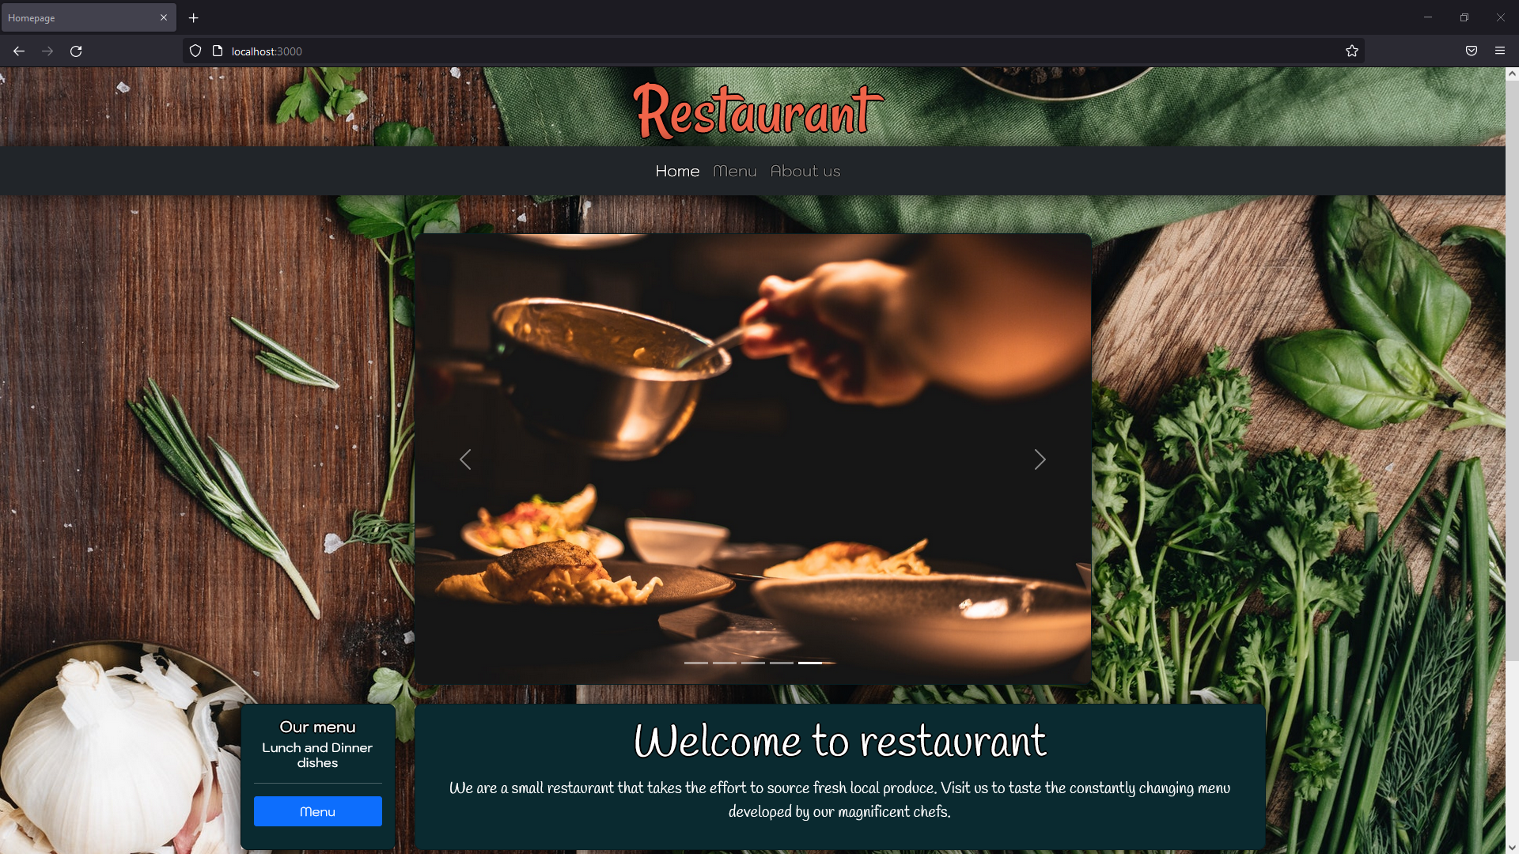

Figure 1 Navigation bar (Not authorized access)

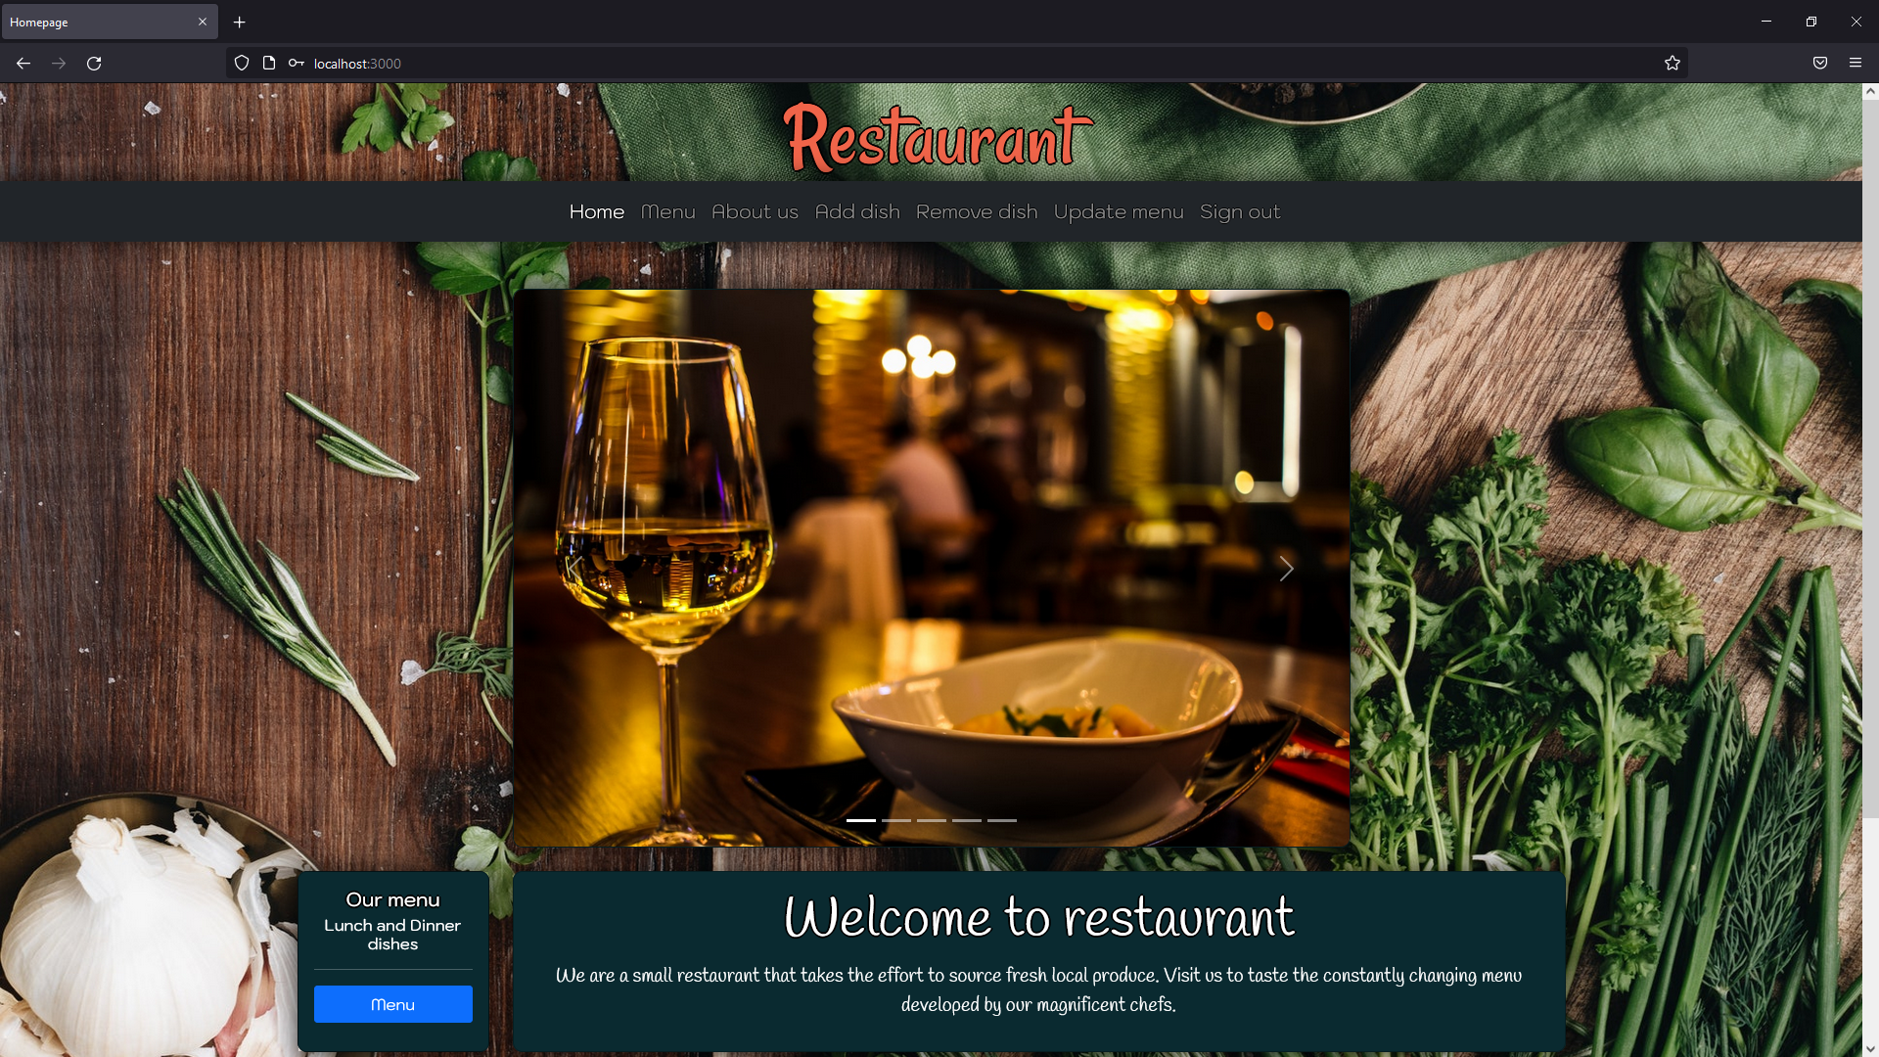

Figure 2 Navigation bar (Authorized access)

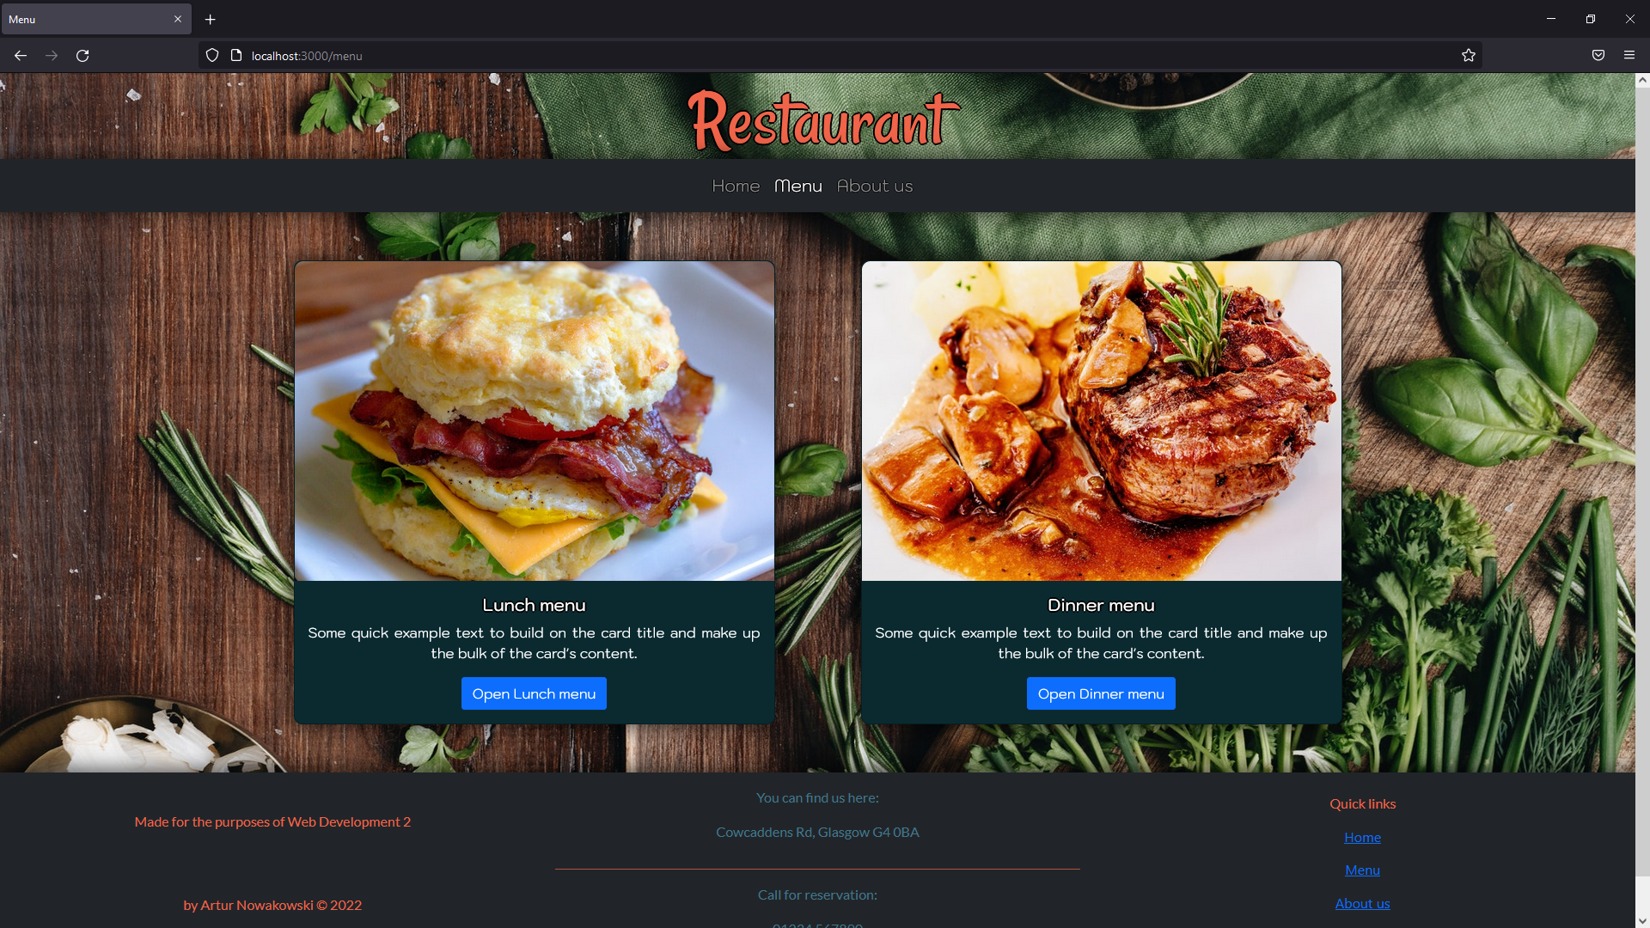

Figure 3 Navigation bar - Menu

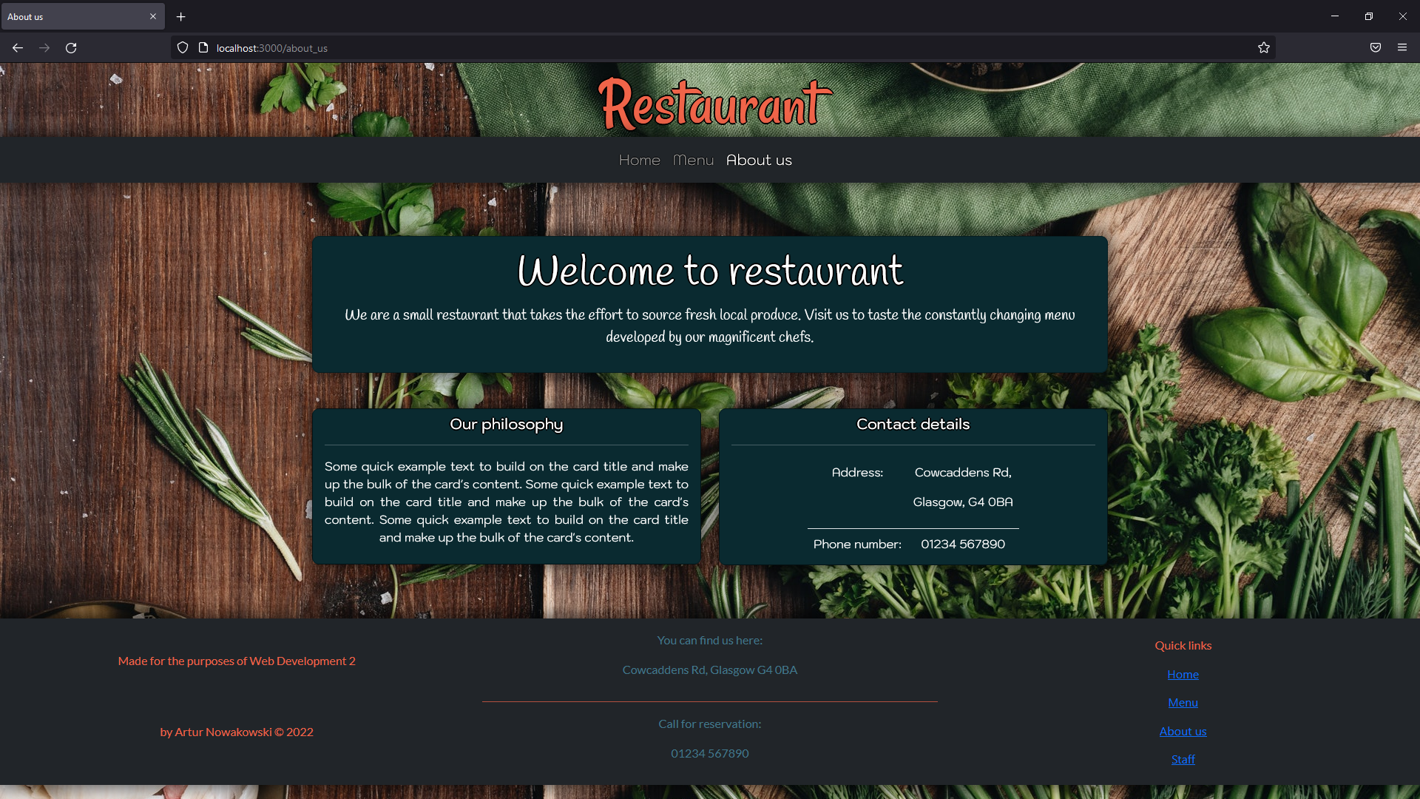

Figure 4 Navigation bar - About us

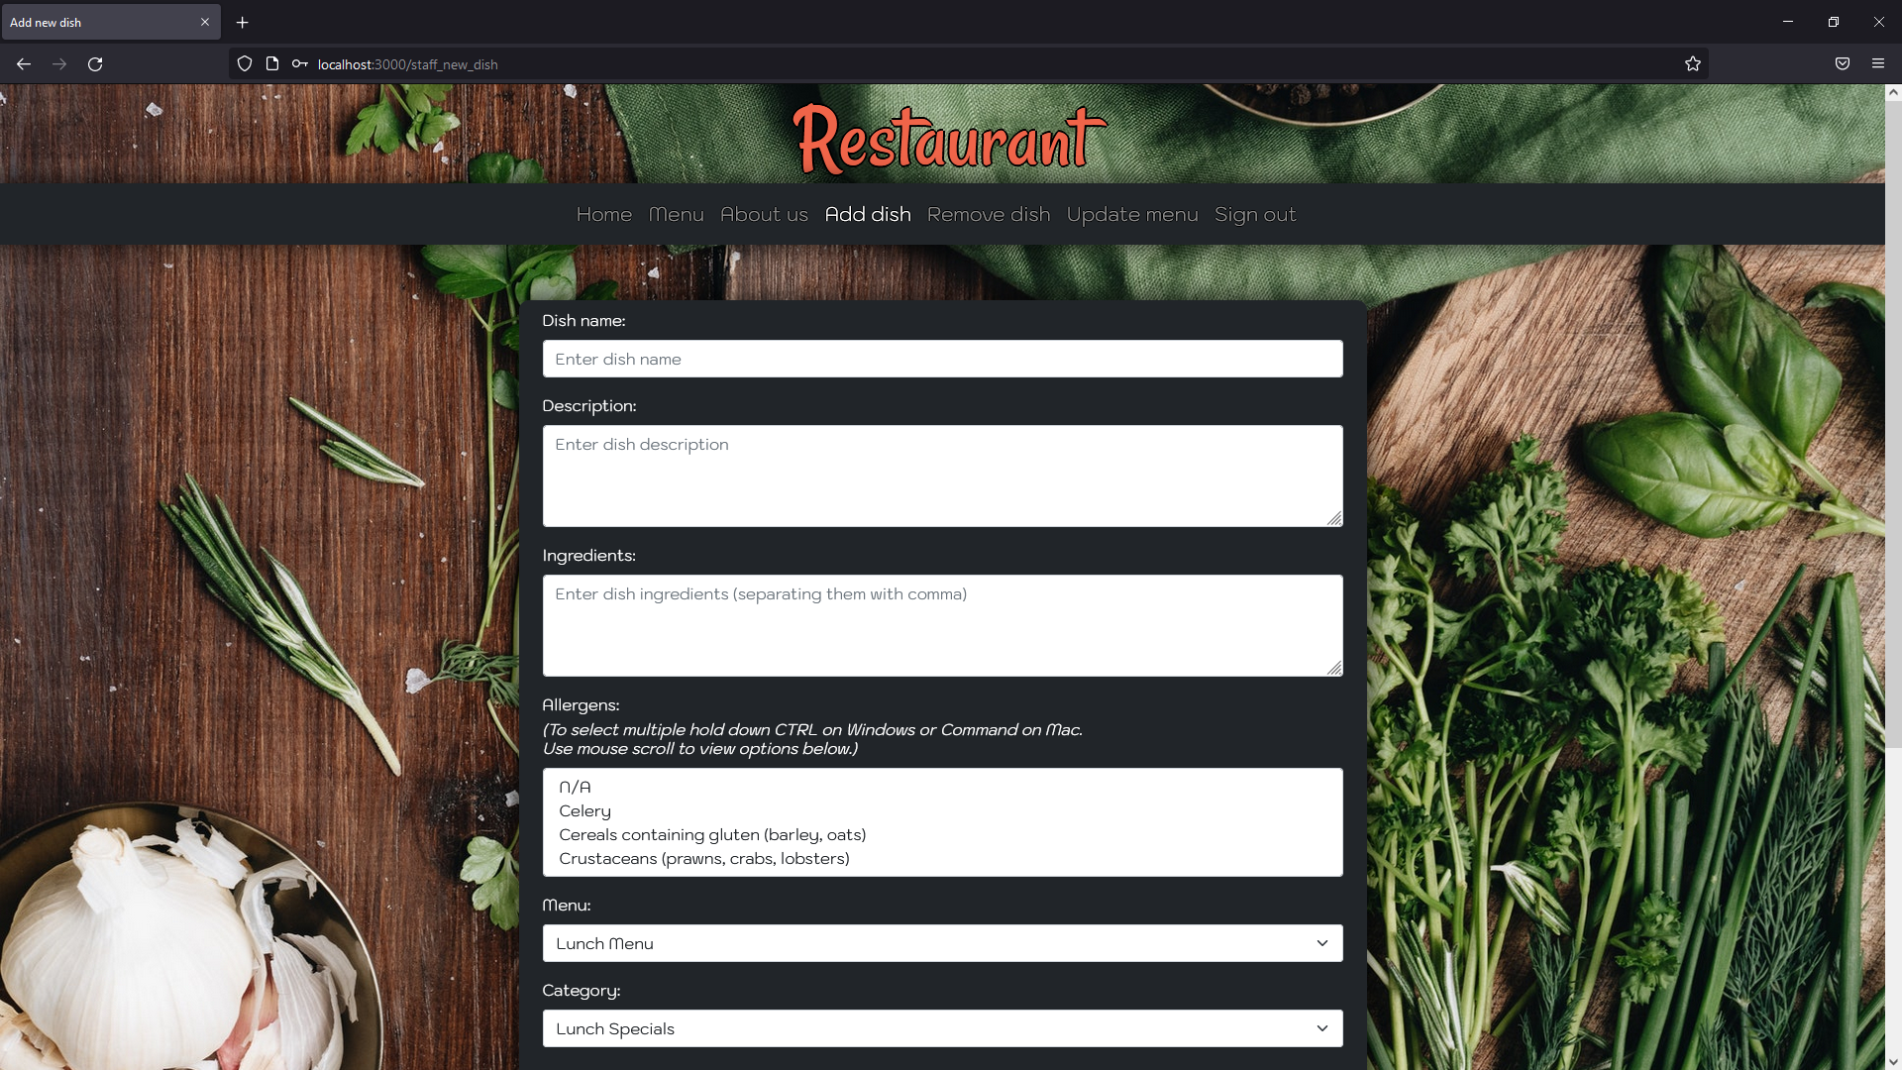

Figure 5 Navigation bar - Add dish

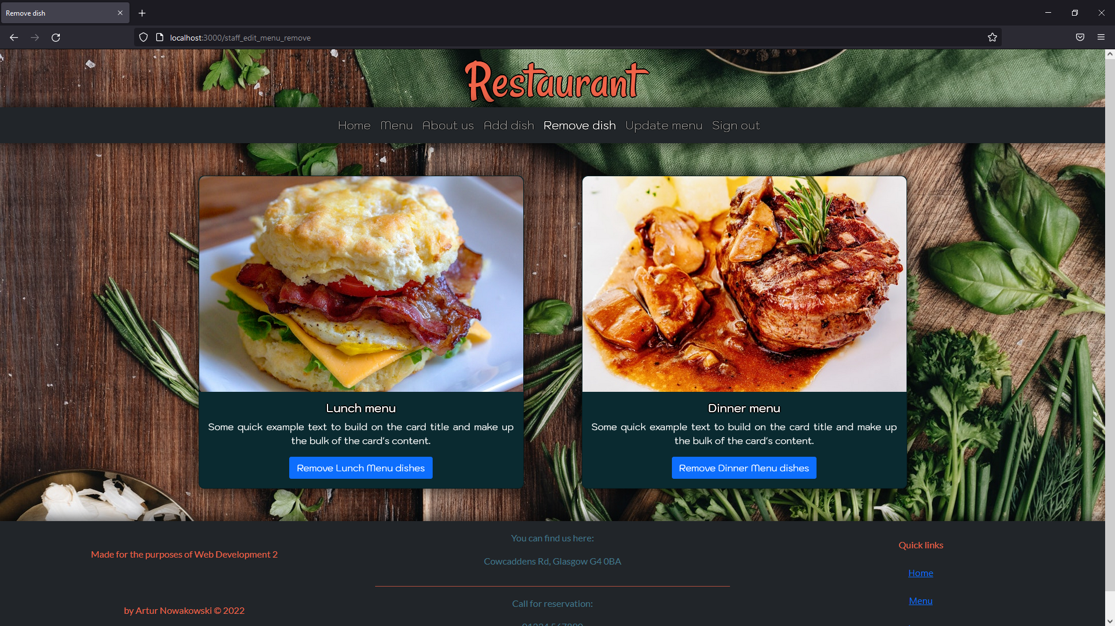

Figure 6 Navigation bar - Remove dish

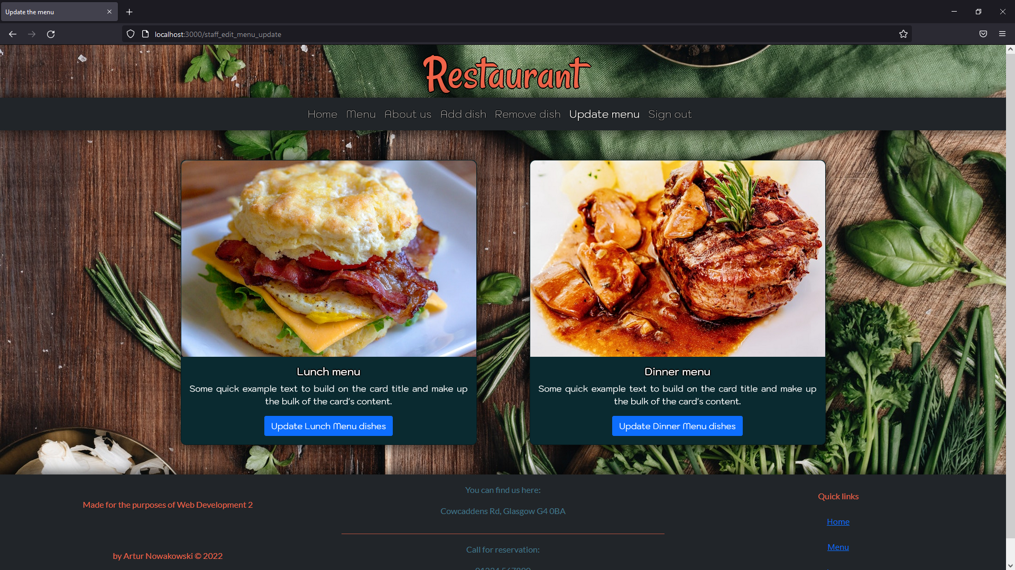

Figure 7 Navigation bar - Update menu

## Footer.

Table 2 Footer testing

|  |  |  |  |  |  |  |
| --- | --- | --- | --- | --- | --- | --- |
| Test ID | Test Case | Action | Expected result | Actual result | Evidence | Passed Y/N |
| 2.1 | Footer - Displays | http://localhost:3000/ | Footer is being displayed. | The same as expected result. | Look at Figure 8 Footer. | Y |
| 2.2 | Footer (Navigation) - Home | Click “Home”. | Homepage loads. | The same as expected result. | Result is the same as Figure 1 Navigation bar (Not authorized access). | Y |
| 2.3 | Footer (Navigation) - Menu | Click “Menu”. | Menu page loads. | The same as expected result. | Result is the same as Figure 3 Navigation bar - Menu. | Y |
| 2.4 | Footer (Navigation) – About us | Click “About us”. | About us page loads. | The same as expected result. | Result is the same as Figure 4 Navigation bar - About us. | Y |
| 2.5 | Footer (Navigation) - Staff | Click “Staff”. | Staff sign in page loads. | The same as expected result. | Look at Figure 9 Footer - Staff. | Y |

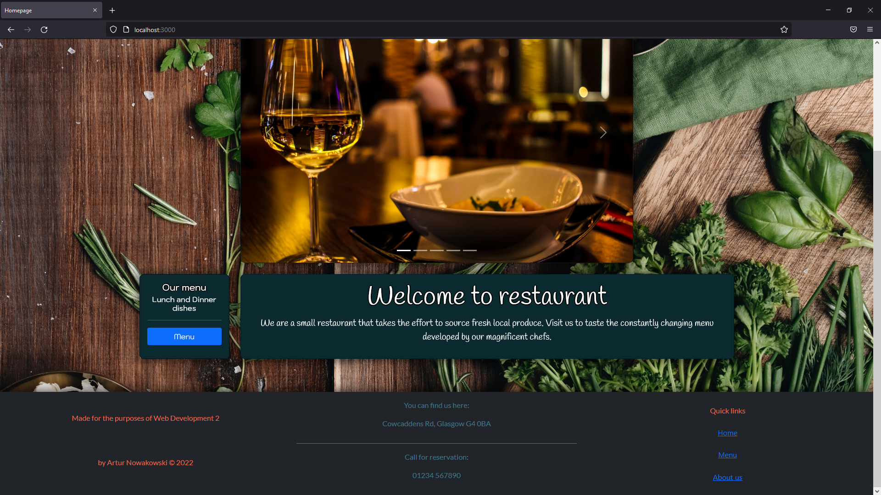

Figure 8 Footer

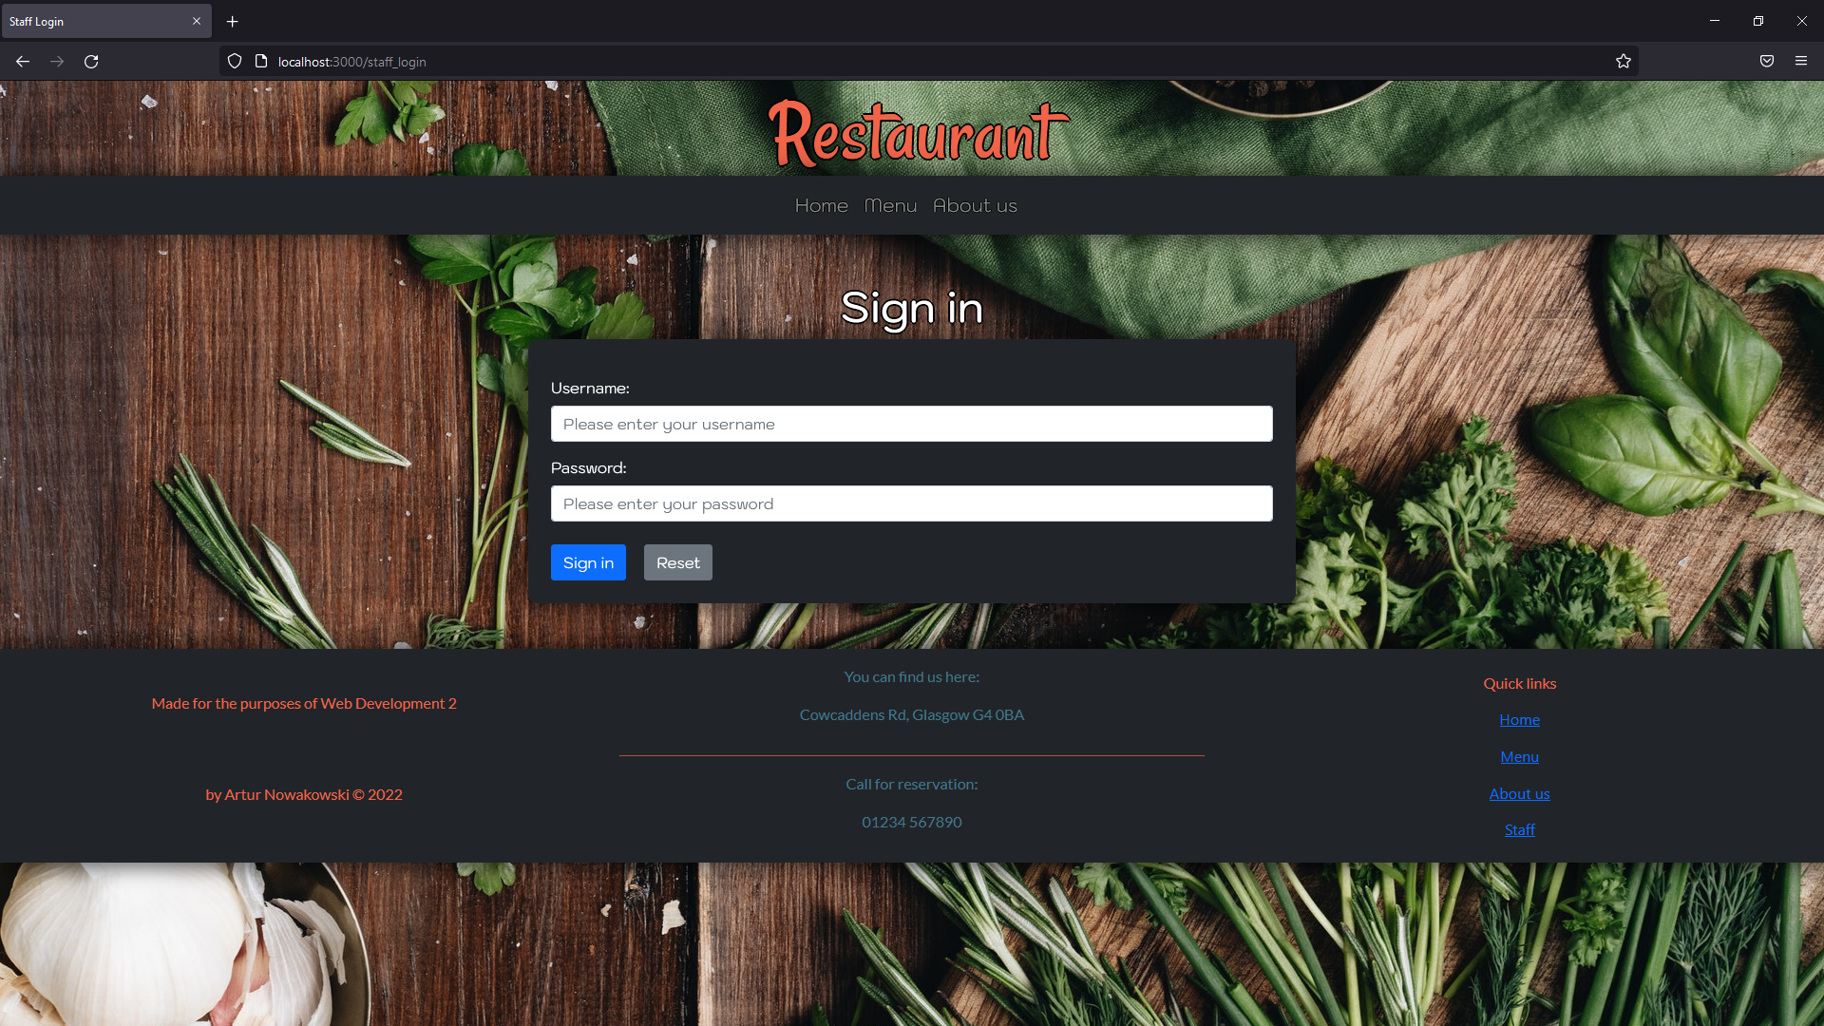

Figure 9 Footer - Staff

## Landing page/Homepage.

Table 3 Landing page/Homepage testing

|  |  |  |  |  |  |  |
| --- | --- | --- | --- | --- | --- | --- |
| Test ID | Test Case | Action | Expected result | Actual result | Evidence | Passed Y/N |
| 3.1 | Landing page/Homepage - Displays | http://localhost:3000/ | Landing page loads and displays working carousel with images, Check our menu card, and Welcome to restaurant element. | The same as expected result. | Result is the same as Figure 1 Navigation bar (Not authorized access). | Y |
| 3.2 | Landing page/Homepage – Menu button | Click “Menu” button on the Check our menu card. | Menu page loads. | The same as expected result. | Result is the same as Figure 3 Navigation bar - Menu. | Y |

## Menu page.

Table 4 Menu page testing

|  |  |  |  |  |  |  |
| --- | --- | --- | --- | --- | --- | --- |
| Test ID | Test Case | Action | Expected result | Actual result | Evidence | Passed Y/N |
| 4.1 | Menu page - Displays | Click “Menu” on the navigation bar or go to http://localhost:3000/menu. | Menu page displays two cards that represent Lunch and Dinner menus. | The same as expected result. | Result is the same as Figure 3 Navigation bar - Menu. | Y |
| 4.2 | Menu page – Open Lunch menu button | Click “Open Lunch menu” button. | Lunch menu page loads and displays Go back button and four cards that represent Lunch Specials, Sandwiches, Salads, and Beverages. | The same as expected result. | Look at Figure 10 Menu – Open lunch menu button. | Y |
| 4.3 | Menu page (lunch) – Go back button | Click “Go back” button. | Menu page loads. | The same as expected result. | Result is the same as Figure 3 Navigation bar - Menu. | Y |
| 4.4 | Menu page (lunch) – Lunch specials card | Click “Lunch specials” link. | Lunch specials page loads and displays Go back button along with a table with available dishes. Provides information like dish name, description, ingredients, allergens, and price. | The same as expected result. | Look at Figure 11 Menu (lunch) - Lunch specials. | Y |
| 4.5 | Menu page (lunch) – Lunch specials page Go back button | Click “Go back” button. | Lunch menu page loads. | The same as expected result. | Result is the same as Figure 3 Navigation bar - Menu. | Y |
| 4.6 | Menu page (lunch) – Sandwiches card | Click “Sandwiches” link. | Sandwiches page loads and displays Go back button along with a table with available dishes. Provides information like dish name, description, ingredients, allergens, and price. | The same as expected result. | Look at Figure 12 Menu (lunch) - Sandwiches. | Y |
| 4.7 | Menu page (lunch) – Sandwiches page Go back button | Click “Go back” button. | Lunch menu page loads. | The same as expected result. | Result is the same as Figure 3 Navigation bar - Menu. | Y |
| 4.8 | Menu page (lunch) – Salad’s card | Click “Salads” link. | Salad’s page loads and displays Go back button along with a table with available dishes. Provides information like dish name, description, ingredients, allergens, and price. | The same as expected result. | Look at Figure 13 Menu (lunch) - Salad. | Y |
| 4.9 | Menu page (lunch) –Salad’s page Go back button | Click “Go back” button. | Lunch menu page loads. | The same as expected result. | Result is the same as Figure 3 Navigation bar - Menu. | Y |
| 4.10 | Menu page (lunch) – Beverage’s card | Click “Beverages” link. | Beverage’s page loads and displays Go back button along with a table with available dishes. Provides information like dish name, description, ingredients, allergens, and price. | The same as expected result. | Look at Figure 14 Menu (lunch) - Beverages. | Y |
| 4.11 | Menu page (lunch) – Beverage’s page Go back button | Click “Go back” button. | Lunch menu page loads. | The same as expected result. | Result is the same as Figure 3 Navigation bar - Menu. | Y |
| 4.12 | Menu page – Open Dinner menu button | Click “Open Dinner menu” button. | Dinner menu page loads and displays Go back button and five cards that represent Appetizers, Sides, Main Course, Desserts, and Beverages. | The same as expected result. | Look at Figure 15 Menu – Open dinner menu button. | Y |
| 4.13 | Menu page (dinner) – Appetizers card | Click “Appetizers” link. | Appetizers page loads and displays Go back button along with a table with available dishes. Provides information like dish name, description, ingredients, allergens, and price. | The same as expected result. | Look at Figure 16 Menu (dinner) - Appetizers. | Y |
| 4.14 | Menu page (dinner) – Appetizers page Go back button | Click “Go back” button. | Menu page loads. | The same as expected result. | Result is the same as Figure 3 Navigation bar - Menu. | Y |
| 4.15 | Menu page (dinner) – Sides card | Click “Sides” link. | Sides page loads and displays Go back button along with a table with available dishes. Provides information like dish name, description, ingredients, allergens, and price. | The same as expected result. | Look at Figure 17 Menu (dinner) - Sides. | Y |
| 4.15 | Menu page (dinner) – Sides page Go back button | Click “Go back” button. | Menu page loads. | The same as expected result. | Result is the same as Figure 3 Navigation bar - Menu. | Y |
| 4.16 | Menu page (dinner) – Main Course card | Click “Main Course” link. | Main Course page loads and displays Go back button along with a table with available dishes. Provides information like dish name, description, ingredients, allergens, and price. | The same as expected result. | Look at Figure 18 Menu (dinner) - Main course. | Y |
| 4.17 | Menu page (dinner) – Main Course page Go back button | Click “Go back” button. | Menu page loads. | The same as expected result. | Result is the same as Figure 3 Navigation bar - Menu. | Y |
| 4.18 | Menu page (dinner) – Dessert’s card | Click “Desserts” link. | Dessert’s page loads and displays Go back button along with a table with available dishes. Provides information like dish name, description, ingredients, allergens, and price. | The same as expected result. | Look at Figure 19 Menu (dinner) - Desserts. | Y |
| 4.19 | Menu page (dinner) – Dessert’s page Go back button | Click “Go back” button. | Menu page loads. | The same as expected result. | Result is the same as Figure 3 Navigation bar - Menu. | Y |
| 4.20 | Menu page (dinner) – Beverage’s card | Click “Beverages” link. | Beverage’s page loads and displays Go back button along with a table with available dishes. Provides information like dish name, description, ingredients, allergens, and price. | The same as expected result. | Look at Figure 20 Menu (dinner) - Beverages. | Y |
| 4.21 | Menu page (dinner) – Beverage’s page Go back button | Click “Go back” button. | Menu page loads. | The same as expected result. | Result is the same as Figure 3 Navigation bar - Menu. | Y |

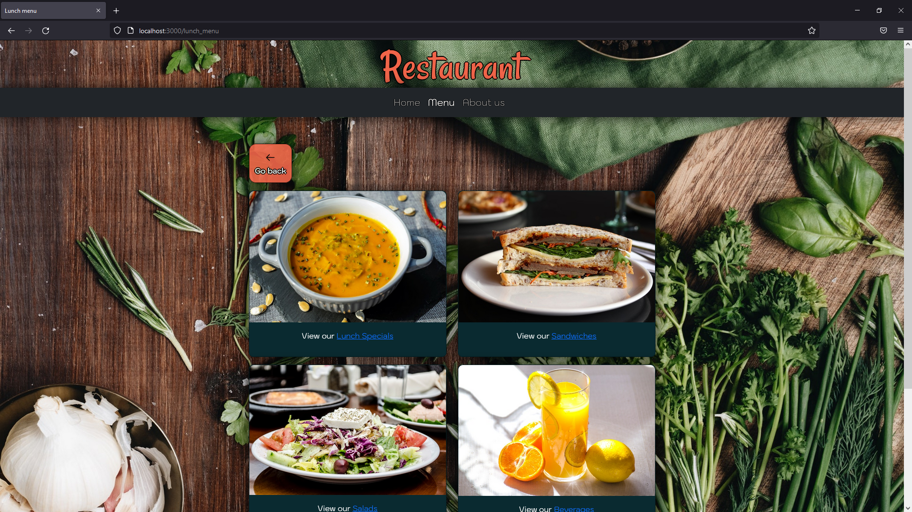

Figure 10 Menu – Open lunch menu button

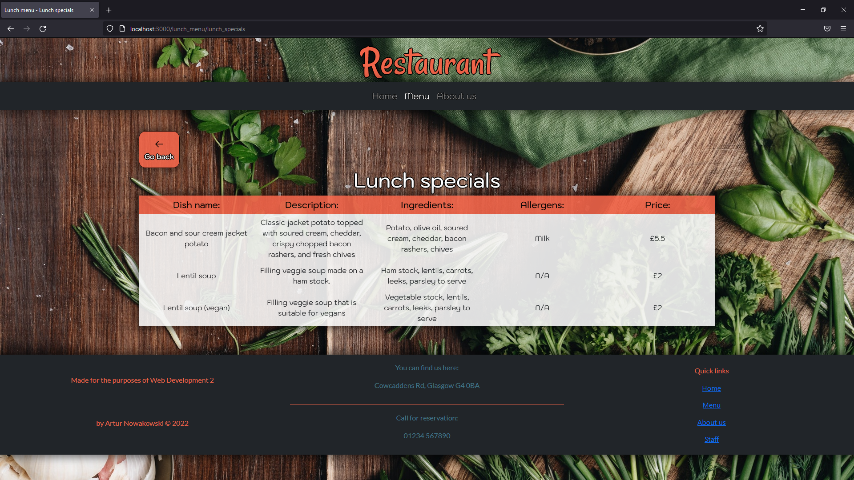

Figure 11 Menu (lunch) - Lunch specials

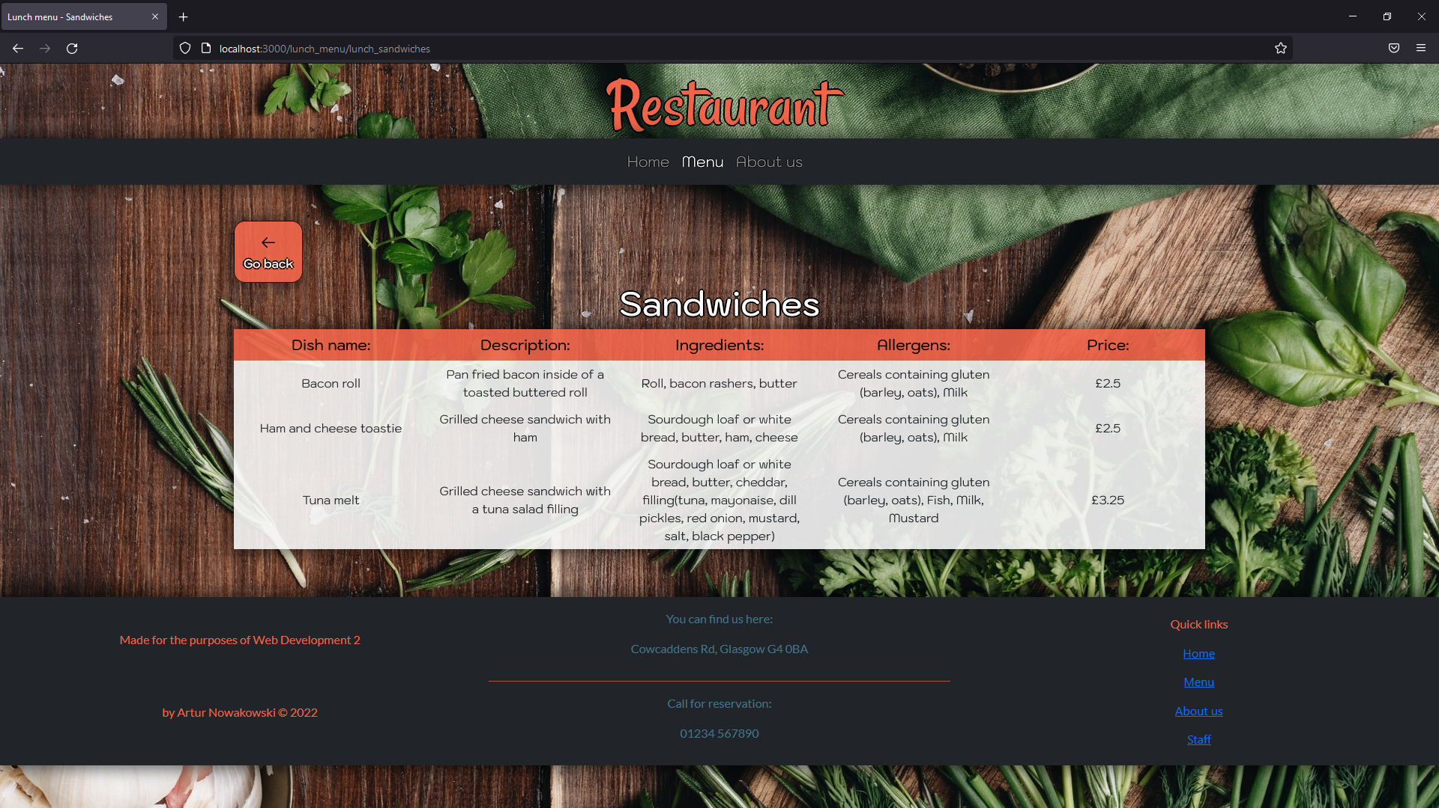

Figure 12 Menu (lunch) - Sandwiches

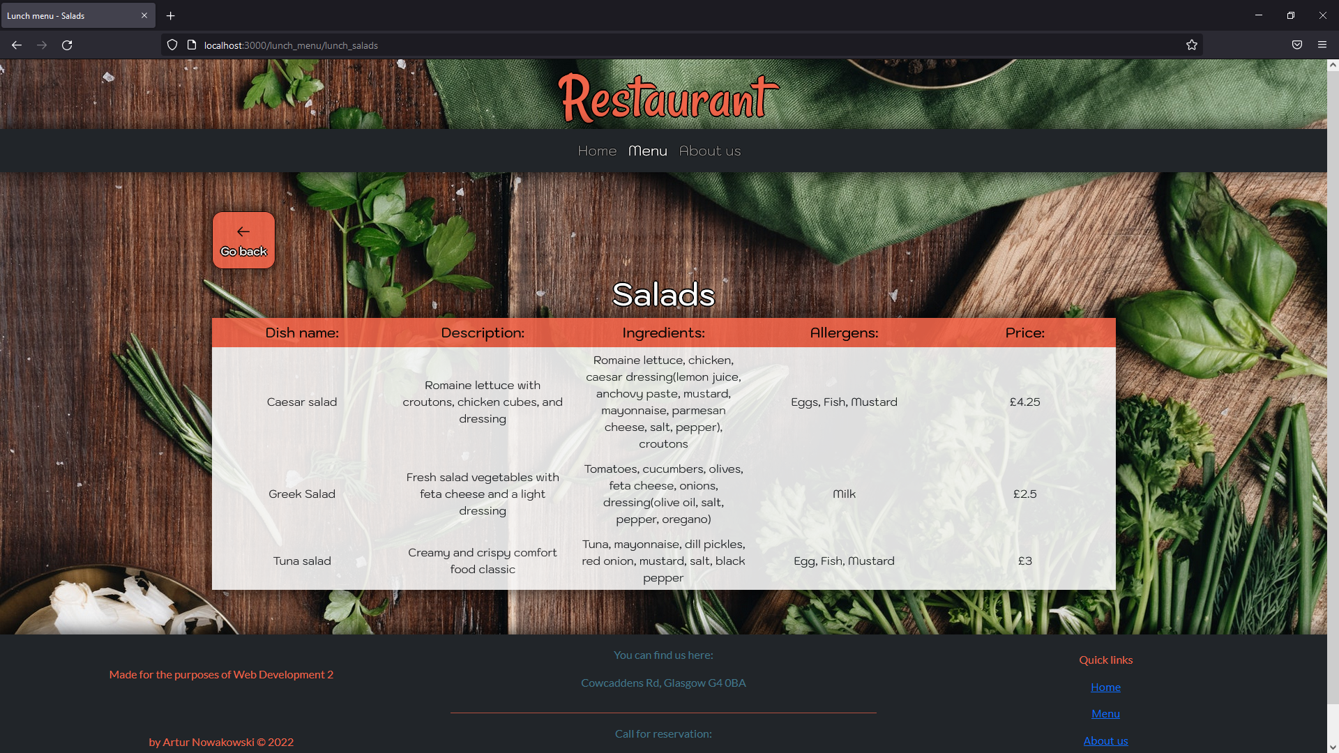

Figure 13 Menu (lunch) - Salads

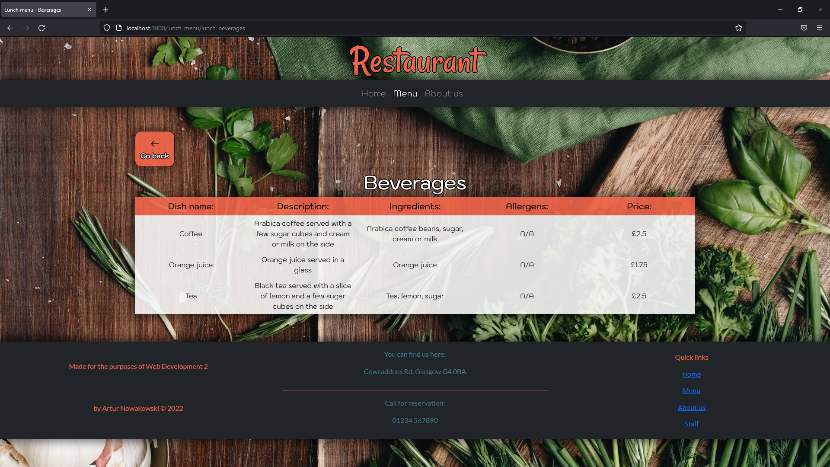

Figure 14 Menu (lunch) - Beverages

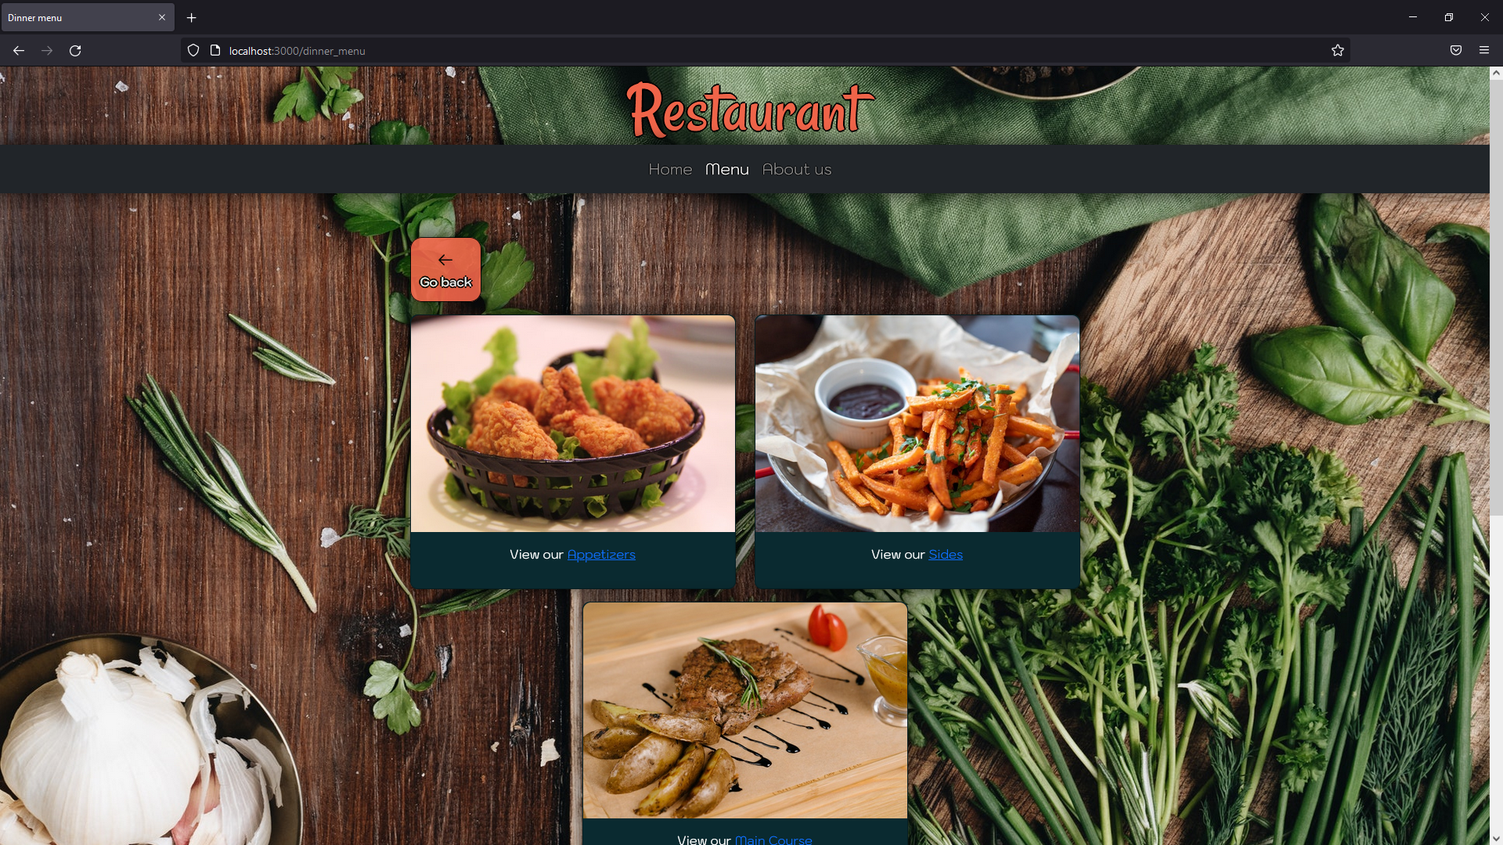

Figure 15 Menu – Open dinner menu button

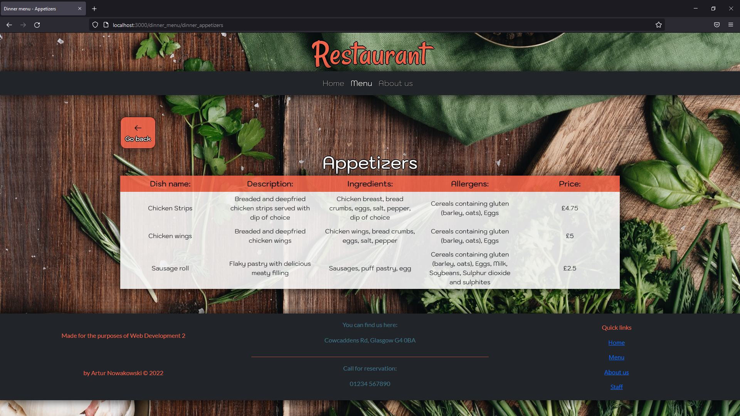

Figure 16 Menu (dinner) - Appetizers

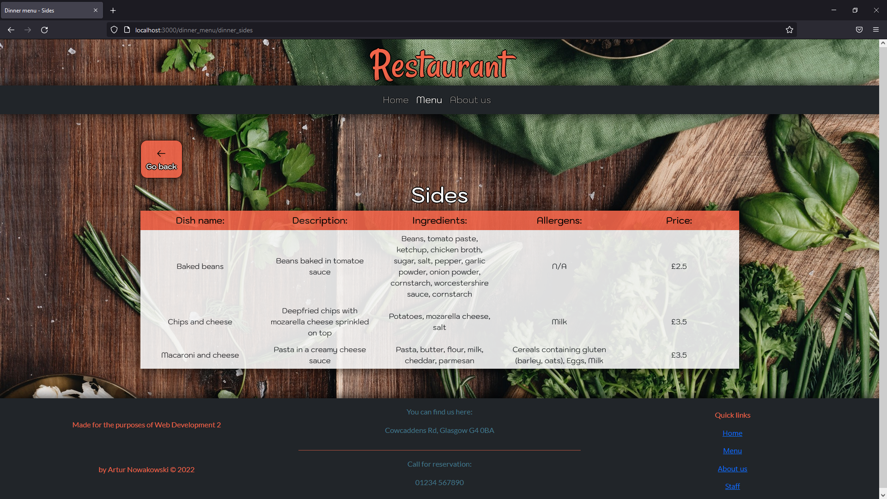

Figure 17 Menu (dinner) - Sides

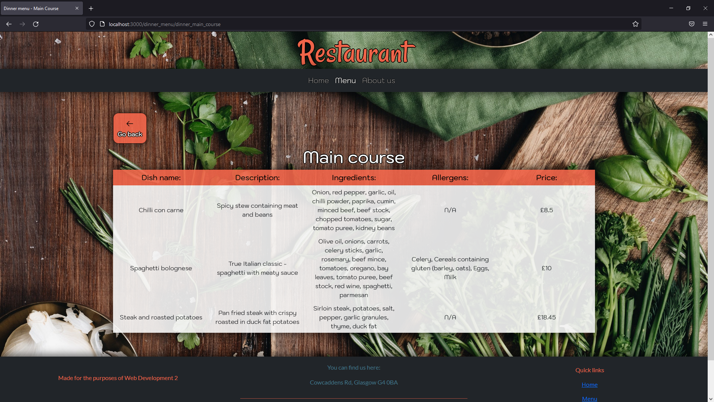

Figure 18 Menu (dinner) - Main course

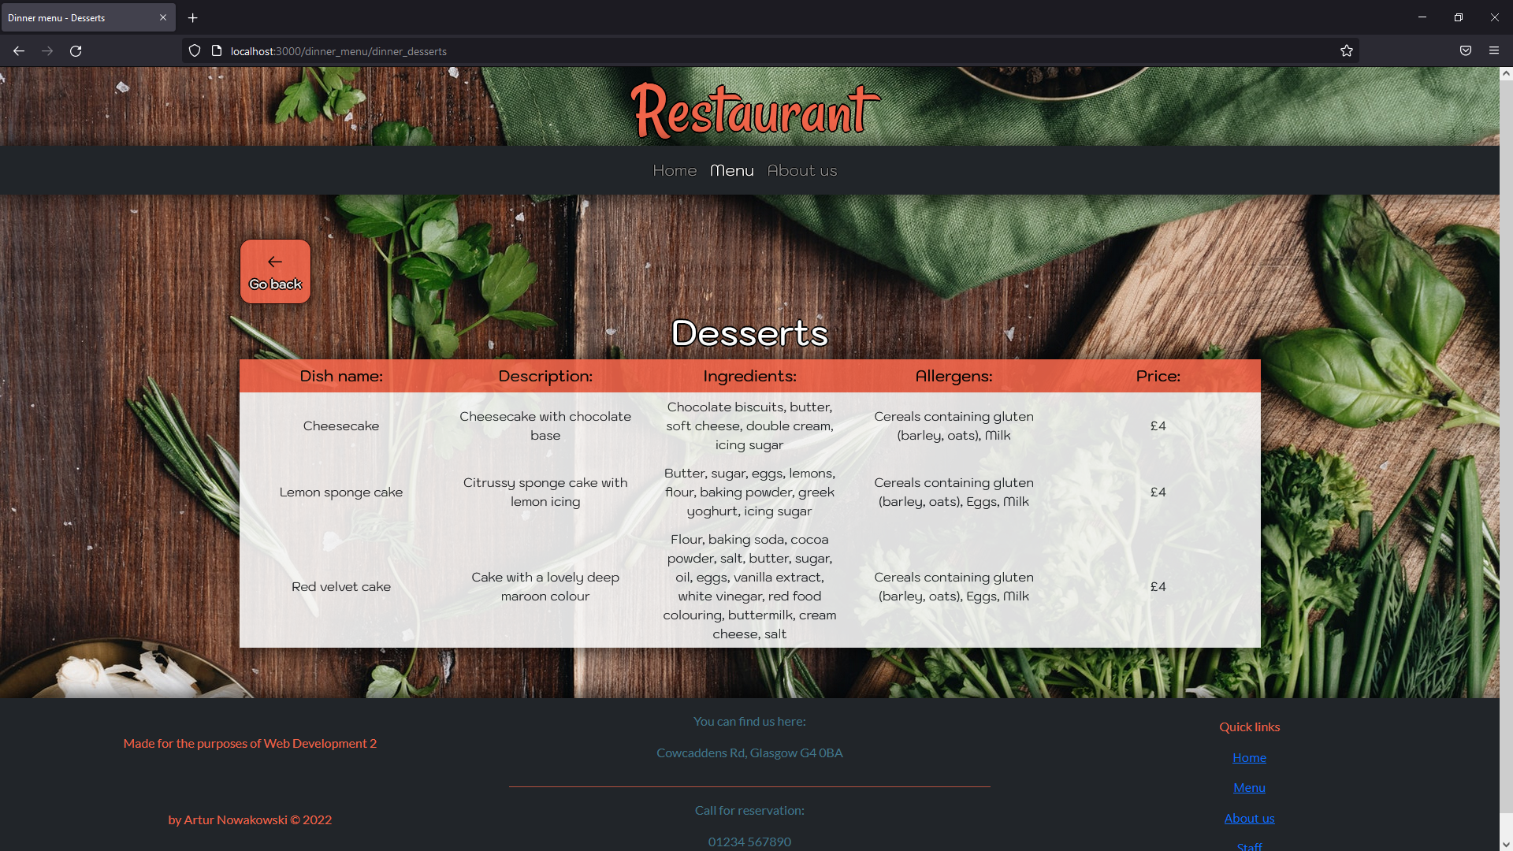

Figure 19 Menu (dinner) - Desserts

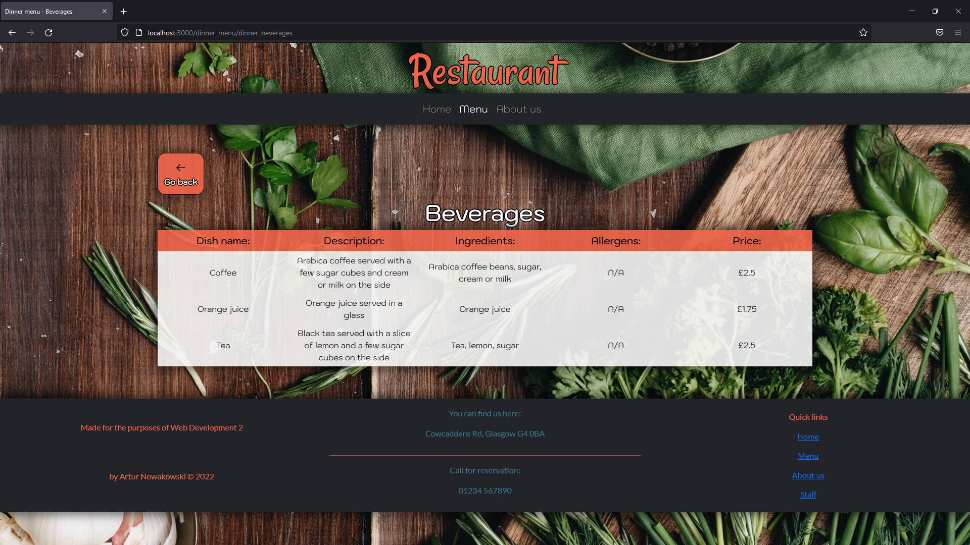

Figure 20 Menu (dinner) - Beverages

## About us.

Table 5 About us page testing

|  |  |  |  |  |  |  |
| --- | --- | --- | --- | --- | --- | --- |
| Test ID | Test Case | Action | Expected result | Actual result | Evidence | Passed Y/N |
| 5.1 | About us page - Displays | Click “About us” on the navigation bar or go to http://localhost:3000/about_us. | About us page displays Welcome to restaurant elements along with two cards that provide philosophy of the restaurant and contact details. | The same as expected result. | Look at Figure 21 About us. | Y |



Figure 21 About us

## Staff sign in.

Table 6 Staff sign in page testing

|  |  |  |  |  |  |  |
| --- | --- | --- | --- | --- | --- | --- |
| Test ID | Test Case | Action | Expected result | Actual result | Evidence | Passed Y/N |
| 6.1 | Staff sign in page - Displays | Click on “Staff” link located in the footer or navigate to http://localhost:3000/staff_login. | Staff sign in page loads and displays a form. | The same as expected result. | Look at Figure 22 Staff sign in. | Y |
| 6.2 | Staff sign in page – Empty form submitted | Attempt to submit an empty form by clicking on “Sign in” button. | Upon submitting an empty form user should be presented with following instructions: “Please provide a username.” and “Please provide a password”. | The same as expected result. | Look at Figure 23 Staff sign in - Empty form submitted. | Y |
| 6.3 | Staff sign in page – User not found | Attempt to sign in using “Peter” as username and “Peter123” as a password. | Upon submitting a filled in form with data that is not in the database, user will be redirected to the staff sign in page and console will display “user Peter not found”. | The same as expected result. | Result is the same as Figure 22 Staff sign in. | Y |
| 6.4 | Staff sign in page – Password not matching | Attempt to sign in using “staff” as username and “Peter123” as a password. | Upon submitting a filled in form with password that does not match with data stored in the database, user will be redirected to the staff sign in page and console will display “password not matching”. | The same as expected result. | Result is the same as Figure 22 Staff sign in. | Y |
| 6.5 | Staff sign in page – Successful | Attempt to sign in using “staff” as username and “staff123” as a password. | Upon submitting a filled in form with data that does match with data stored in the database, user will be redirected to the Homepage and will gain authorization to access pages not available for regular users. | The same as expected result. | Result is the same as Figure 2 Navigation bar (Authorized access). | Y |
| 6.6 | Staff sign out | Click “Sign out” as an authorized user. | Homepage loads and user is signed out. Therefore, loses authorized access. | The same as expected result. | Result is the same as Figure 1 Navigation bar (Not authorized access). | Y |

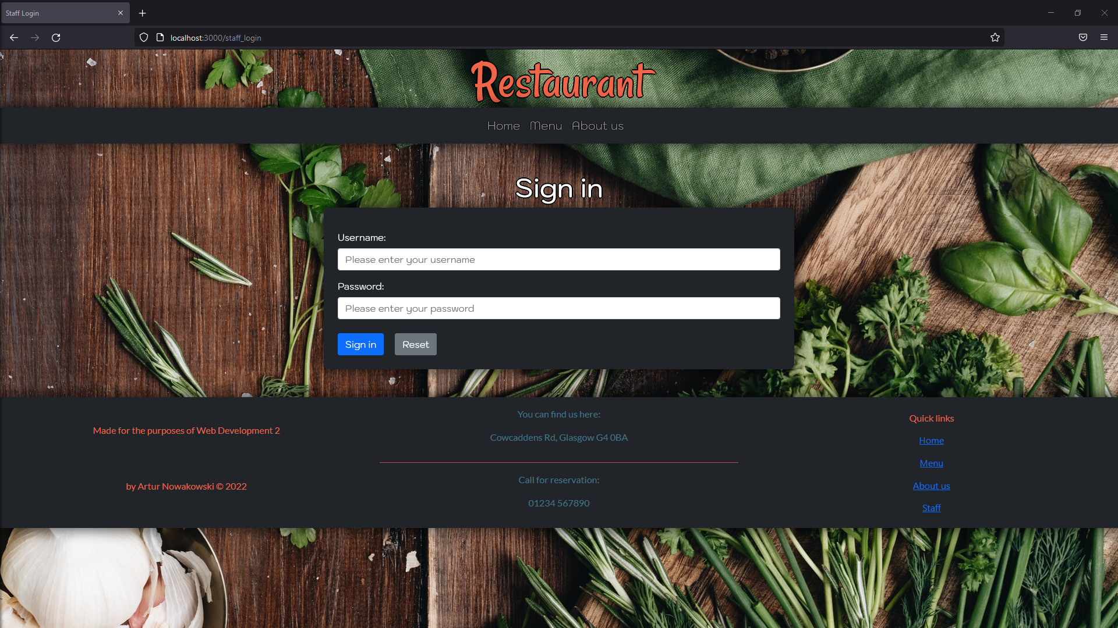

Figure 22 Staff sign in

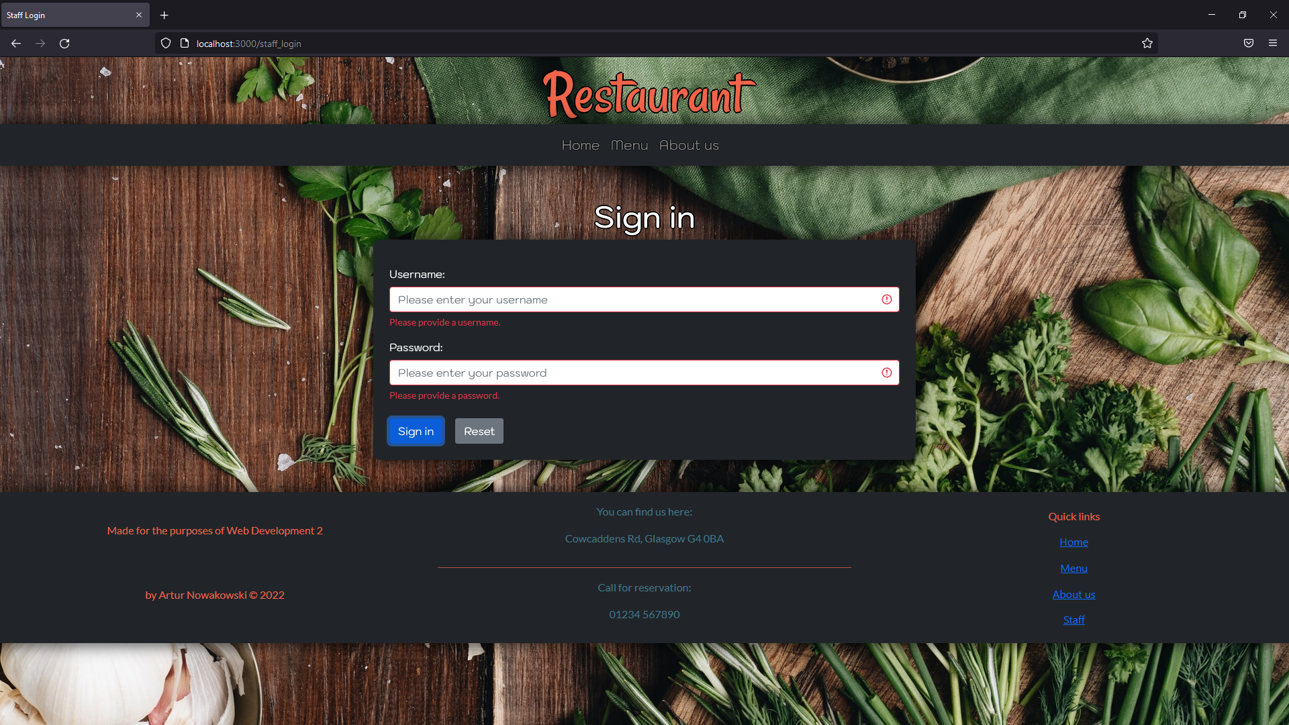

Figure 23 Staff sign in - Empty form submitted

## Add new dish.

Table 7 Add new dish page testing

|  |  |  |  |  |  |  |
| --- | --- | --- | --- | --- | --- | --- |
| Test ID | Test Case | Action | Expected result | Actual result | Evidence | Passed Y/N |
| 7.1 | Add new dish page - Displays | Click on “Add dish” link located in the navigation bar or navigate to http://localhost:3000/ staff_new_dish. | Add new dish page displays a form that allows to insert new dish into a database. | The same as expected result. | Result is the same as Figure 5 Navigation bar - Add dish. | Y |
| 7.2 | Add new dish page – Empty form submitted | Submit an empty form by clicking on “Add new dish” button. | Upon submitting an empty form user should be presented with following instructions: “Please provide a dish name”, “Please provide dish description” etc. | The same as expected result. | Look at Figure 24 Add new dish - Empty form submitted. | Y |
| 7.3 | Add new dish page – Dish exists in the database | Attempt to add a new dish with name “Lentil soup” along with other information. Choose Lunch Menu and Lunch Specials, then submit the form by clicking on a “Add new dish” button. | Upon submitting “Lentil soup” dish user should be redirected to the Add new dish page and console should display “Error inserting document Lentil soup”. | The same as expected result. | Result is the same as Figure 5 Navigation bar - Add dish. | Y |
| 7.4 | Add new dish page - Successful | Attempt to add a new dish with name “Scrambled eggs” along with other information and submit the form by clicking on a “Add new dish” button. | Upon submitting “Scrambled eggs” dish user should be redirected to the Add new dish page and the dish will be inserted into the chosen database. | The same as expected result. | Result is the same as Figure 5 Navigation bar - Add dish, but the dish is inserted into the database. | Y |

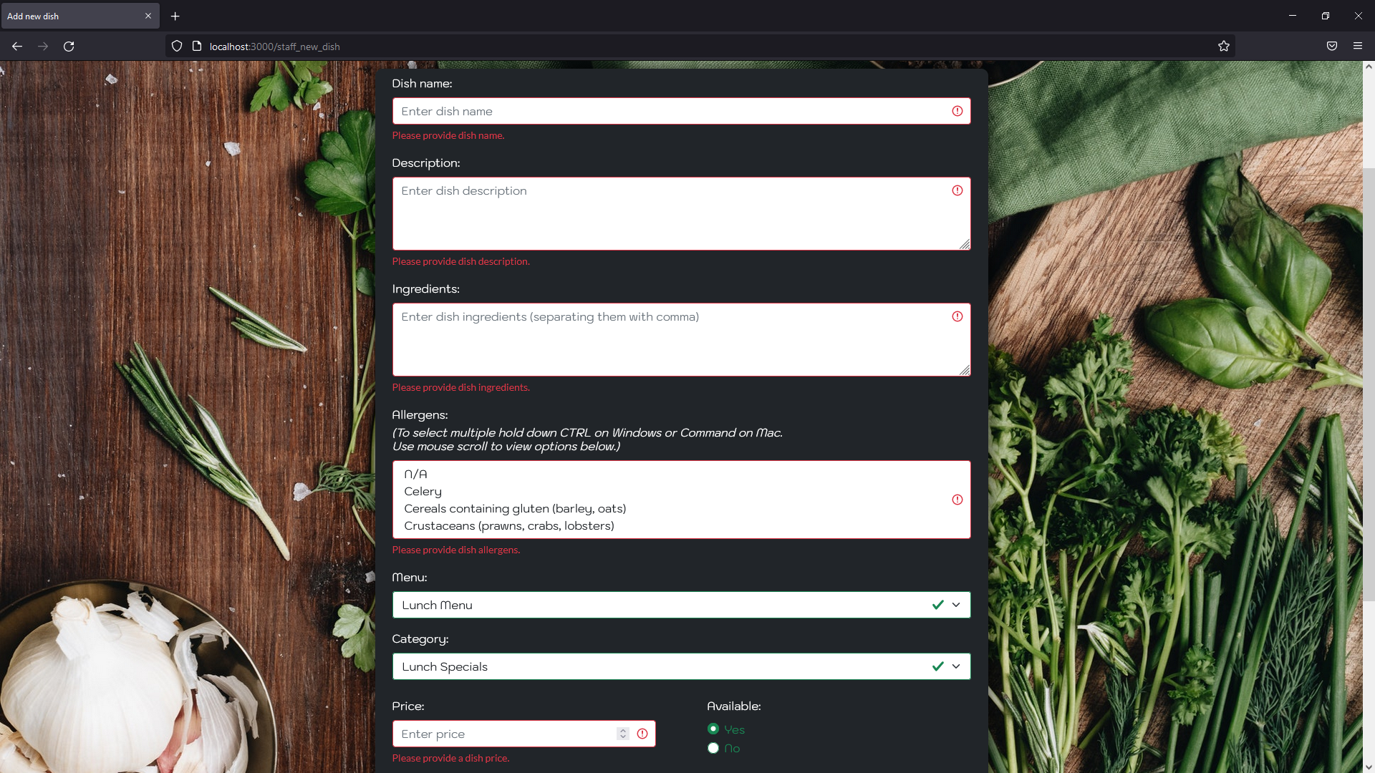

Figure 24 Add new dish - Empty form submitted

## Remove dish.

Table 8 Remove dish page testing

|  |  |  |  |  |  |  |
| --- | --- | --- | --- | --- | --- | --- |
| Test ID | Test Case | Action | Expected result | Actual result | Evidence | Passed Y/N |
| 8.1 | Remove dish page - Displays | Click on “Remove dish” link located in the navigation bar or navigate to http://localhost:3000/staff_edit_menu_remove. | Remove dish page displays two cards that represent Lunch and Dinner menus. | The same as expected result. | Result is the same as Figure 6 Navigation bar - Remove dish. | Y |
| 8.2 | Remove dish page – Remove Lunch Menu dishes button | Click on “Remove Lunch Menu dishes” button. | Remove Lunch Menu page loads and displays Go back button along with a form and a table with all dishes. Table provides information like dish name, category, and availability. | The same as expected result. | Look at Figure 25 Remove dish - Remove lunch menu dishes. | Y |
| 8.3 | Remove dish page (lunch) – Go back button | Click on “Go back” button. | Remove dish page loads. | The same as expected result. | Result is the same as Figure 6 Navigation bar - Remove dish. | Y |
| 8.4 | Remove dish page (lunch) – Empty form submitted | Attempt to submit an empty form. | Upon submitting an empty form user should be presented with following instructions: “Please provide dish name”. | The same as expected result. | Look at Figure 26 Remove dish (lunch) - Empty form submitted. | Y |
| 8.5 | Remove dish page (lunch) - Successful | Copy name of a dish presented in the table below and paste it into the form’s input box, then click on the “Remove dish” button. | Upon submitting dish name user should be redirected to updated page that has the user input dish removed. Additionally, inputted dish is removed from the database. | The same as expected result. | Look at Figure 27 Remove dish (lunch) - Coffee removed and compare it with Figure 25 Remove dish - Remove lunch menu dishes. | Y |
| 8.6 | Remove dish page – Remove Dinner Menu dishes button | Click on “Remove Dinner Menu dishes” button. | Remove Dinner Menu page loads and displays Go back button along with a form and a table with all dishes. Table provides information like dish name, category, and availability. | The same as expected result. | Look at Figure 28 Remove dish - Remove dinner menu dishes. | Y |
| 8.7 | Remove dish page (dinner) – Go back button | Click on “Go back” button. | Remove dish page loads. | The same as expected result. | Result is the same as Figure 6 Navigation bar - Remove dish. | Y |
| 8.8 | Remove dish page (dinner) – Empty form submitted | Attempt to submit an empty form by clicking on the “Remove dish” button. | Upon submitting an empty form user should be presented with following instructions: “Please provide dish name”. | The same as expected result. | Look at Figure 29 Remove dish (dinner) - Empty form submitted. | Y |
| 8.9 | Remove dish page (dinner) - Successful | Copy name of a dish presented in the table below and paste it into the form’s input box, then click on the “Remove dish” button. | Upon submitting dish name user should be redirected to updated page that has the user input dish removed. Additionally, inputted dish is removed from the database. | The same as expected result. | Look at Figure 30 Remove dish (dinner) - Chicken strips removed and compare it with Figure 28 Remove dish - Remove dinner menu dishes. | Y |

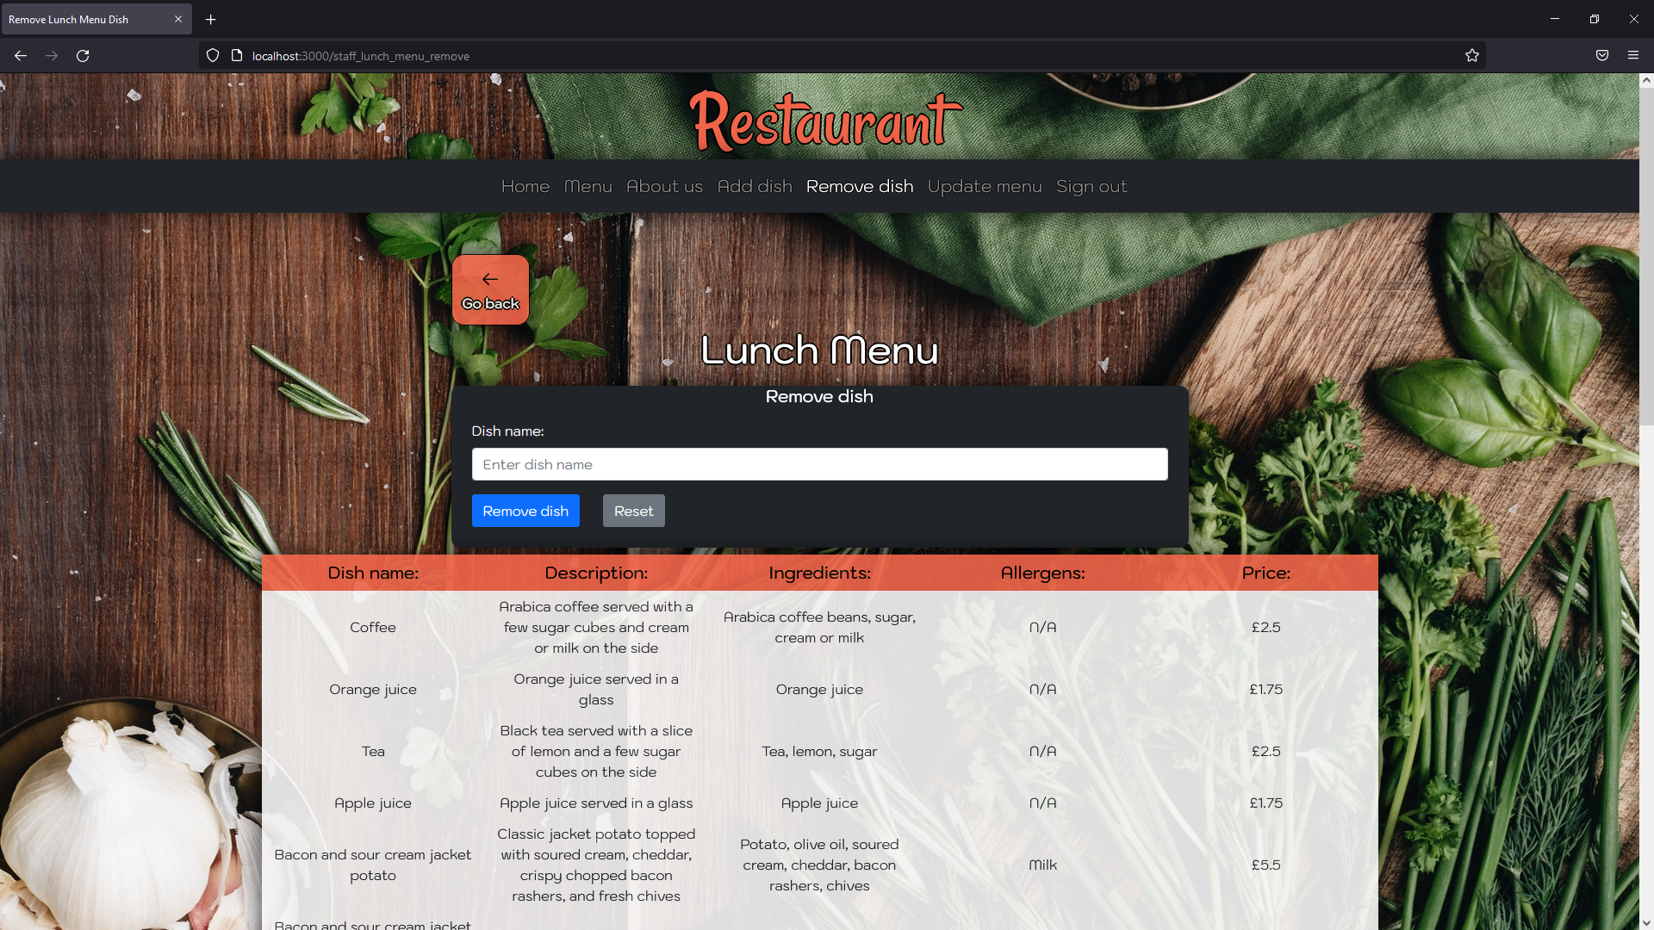

Figure 25 Remove dish - Remove lunch menu dishes

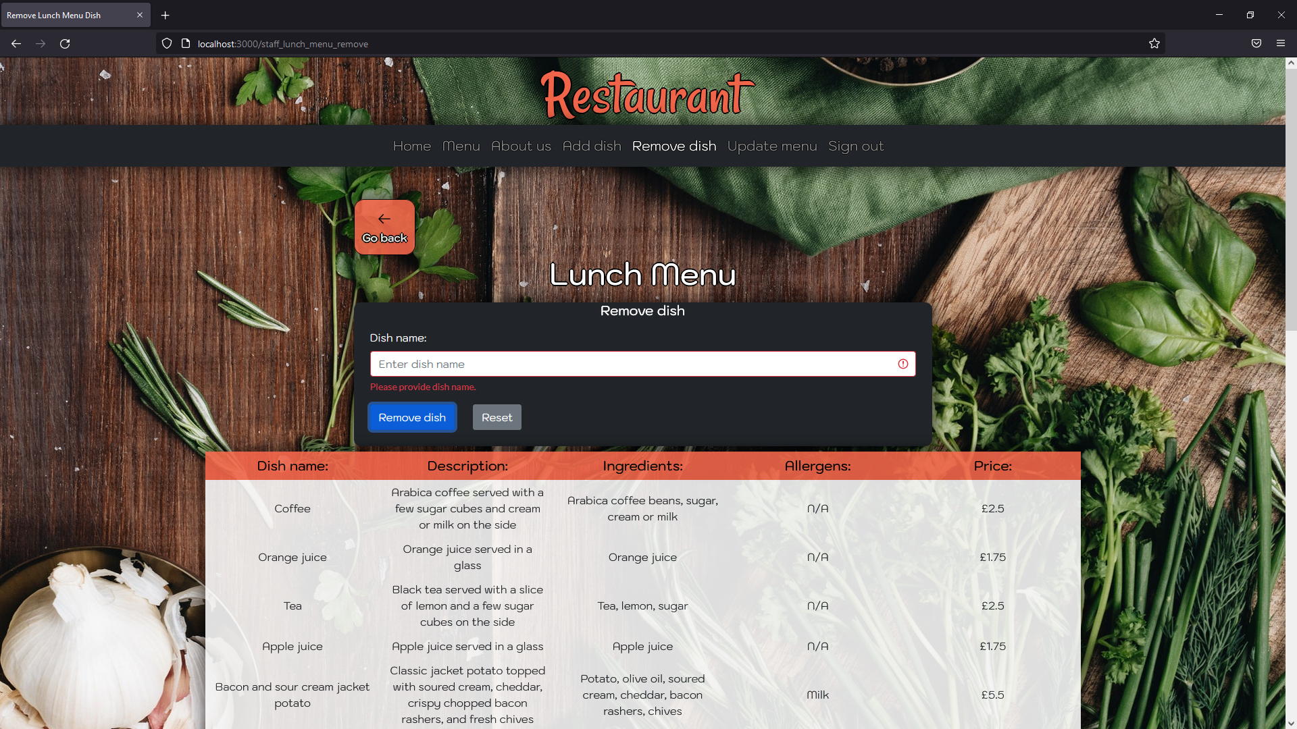

Figure 26 Remove dish (lunch) - Empty form submitted

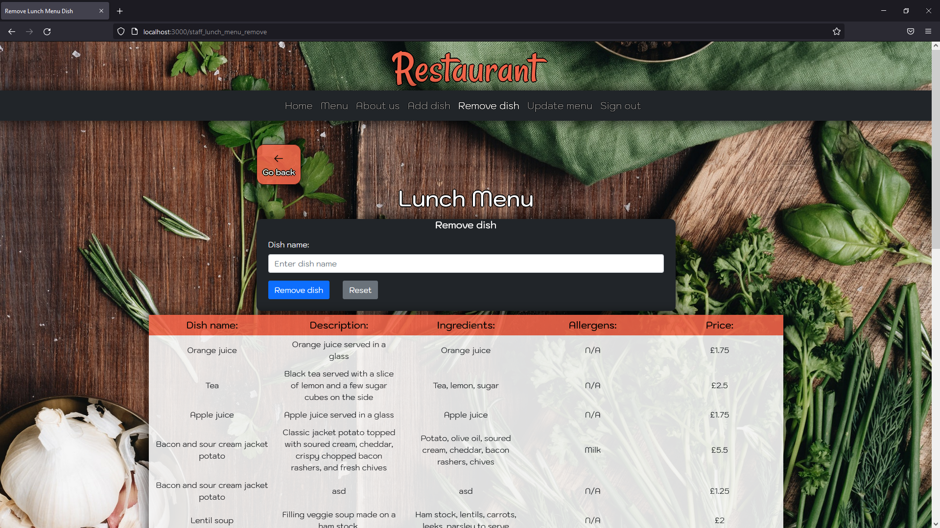

Figure 27 Remove dish (lunch) - Coffee removed

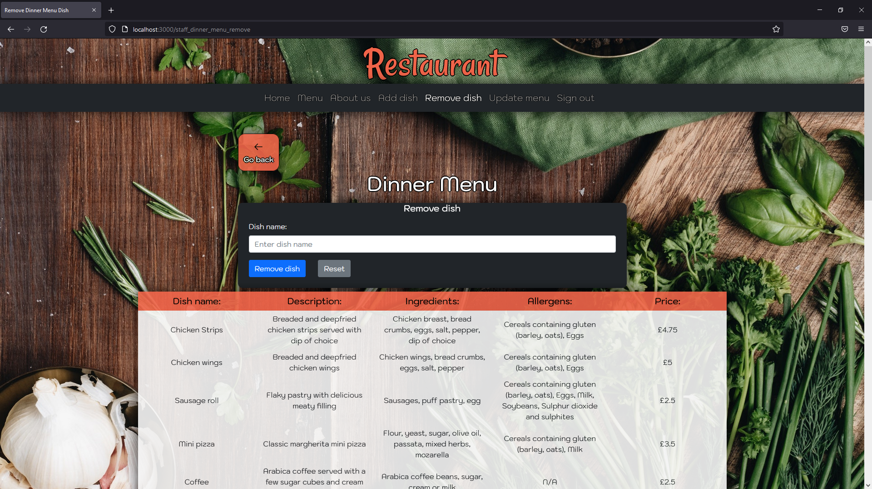

Figure 28 Remove dish - Remove dinner menu dishes

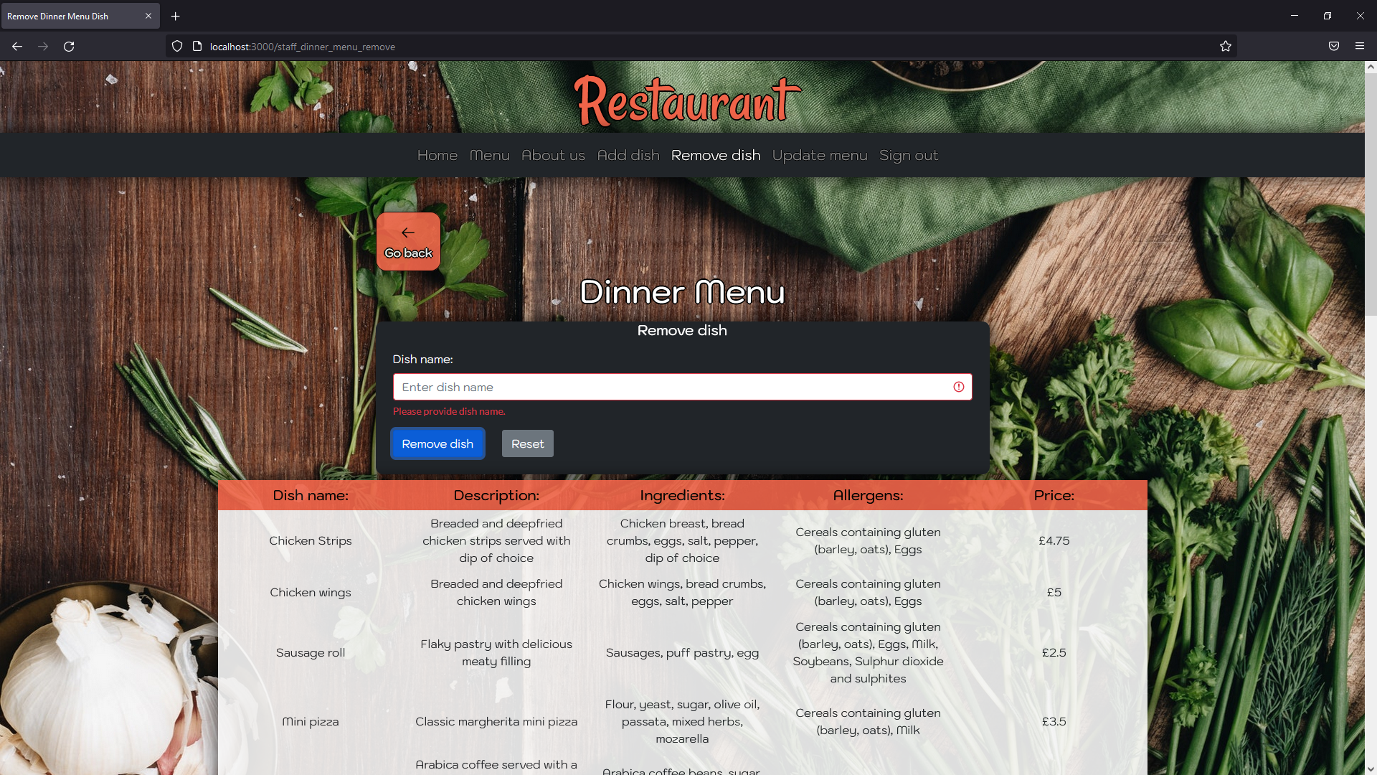

Figure 29 Remove dish (dinner) - Empty form submitted

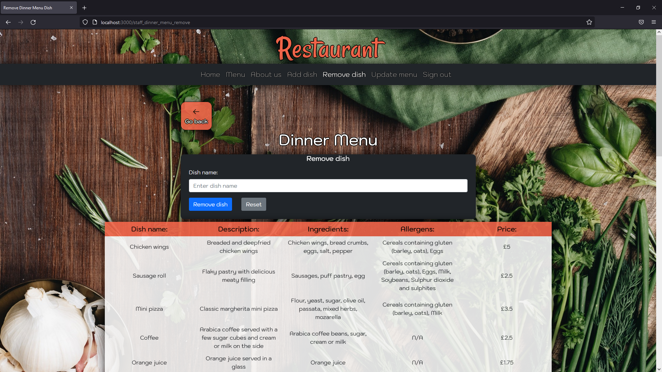

Figure 30 Remove dish (dinner) - Chicken strips removed

## Update menu.

Table 9 Update menu page testing

|  |  |  |  |  |  |  |
| --- | --- | --- | --- | --- | --- | --- |
| Test ID | Test Case | Action | Expected result | Actual result | Evidence | Passed Y/N |
| 9.1 | Update menu page - Displays | Click on “Update menu” link located in the navigation bar or navigate to http://localhost:3000/staff_edit_menu_update. | Edit the menu page displays two cards that represent Lunch and Dinner menus. | The same as expected result. | Result is the same as Figure 7 Navigation bar - Update menu. | Y |
| 9.2 | Update menu page – Update Lunch Menu dishes button | Click on “Update Lunch Menu dishes” button. | Update Lunch Menu dish page loads and displays Go back button along with a form and a table with all dishes. Table provides information like dish name, category, and availability. | The same as expected result. | Look at Figure 31 Update menu - Update lunch menu dishes. | Y |
| 9.3 | Update menu page (lunch) - Go back button | Click on “Go back” button. | Update the menu page loads. | The same as expected result. | Result is the same as Figure 7 Navigation bar - Update menu. | Y |
| 9.4 | Update menu page (lunch) – Empty form submitted (choose dish form) | Attempt to submit an empty form by clicking on “Edit dish” button. | Upon submitting an empty form user should be presented with following instructions: “Please provide dish name”. | The same as expected result. | Look at Figure 32 Update menu (lunch) - Empty form submitted. | Y |
| 9.5 | Update menu page (lunch) – Successful (choose dish form) | Copy name of a dish presented in the table below and paste it into the form’s input box, then click on the “Remove dish” button. | Upon submitting dish name user should be presented with a new form that is filled in with data retrieved from the database. | The same as expected result. | Look at Figure 33 Update menu (lunch) - Orange juice. | Y |
| 9.6 | Update menu page (lunch) – Successful (edit chosen dish form) | Edit form input boxes and submit the changes by clicking on “Update dish” button. | Upon submitting edited dish form user is redirected to the Edit Lunch Menu dish page, where recently edited dish is updated. Additionally, changes are reflected in the database. | The same as expected result. | Look at Figure 34 Update menu (lunch) - Orange juice edited and compare it with Figure 31 Update menu - Update lunch menu dishes. | Y |
| 9.7 | Update menu page – Update Dinner Menu dishes button | Click on “Update Dinner Menu dishes” button. | Update Dinner Menu dish page loads and displays Go back button along with a form and a table with all dishes. Table provides information like dish name, category, and availability. | The same as expected result. | Look at Figure 35 Update menu - Update dinner menu dishes. | Y |
| 9.8 | Update menu page (dinner) - Go back button | Click on “Go back” button. | Update the menu page loads. | The same as expected result. | Result is the same as Figure 7 Navigation bar - Update menu. | Y |
| 9.9 | Update menu page (dinner) – Empty form submitted (choose dish form) | Attempt to submit an empty form by clicking on “Edit dish” button. | Upon submitting an empty form user should be presented with following instructions: “Please provide dish name”. | The same as expected result. | Look at Figure 36 Update menu (dinner) - Empty form submitted. | Y |
| 9.10 | Update menu page (dinner) – Successful (choose dish form) | Copy name of a dish presented in the table below and paste it into the form’s input box, then click on the “Remove dish” button. | Upon submitting dish name user should be presented with a new form that is filled in with data retrieved from the database. | The same as expected result. | Look at Figure 37 Update menu (dinner) - Chicken wings. | Y |
| 9.11 | Update the menu page (dinner) – Successful (edit chosen dish form) | Edit form input boxes and submit the changes by clicking on “Update dish” button. | Upon submitting edited dish form user is redirected to the Edit Dinner Menu dish page, where recently edited dish is updated. Additionally, changes are reflected in the database. | The same as expected result. | Look at Figure 38 Update menu (dinner) - Chicken wings edited and compare it with Figure 35 Update menu - Update dinner menu dishes. | Y |

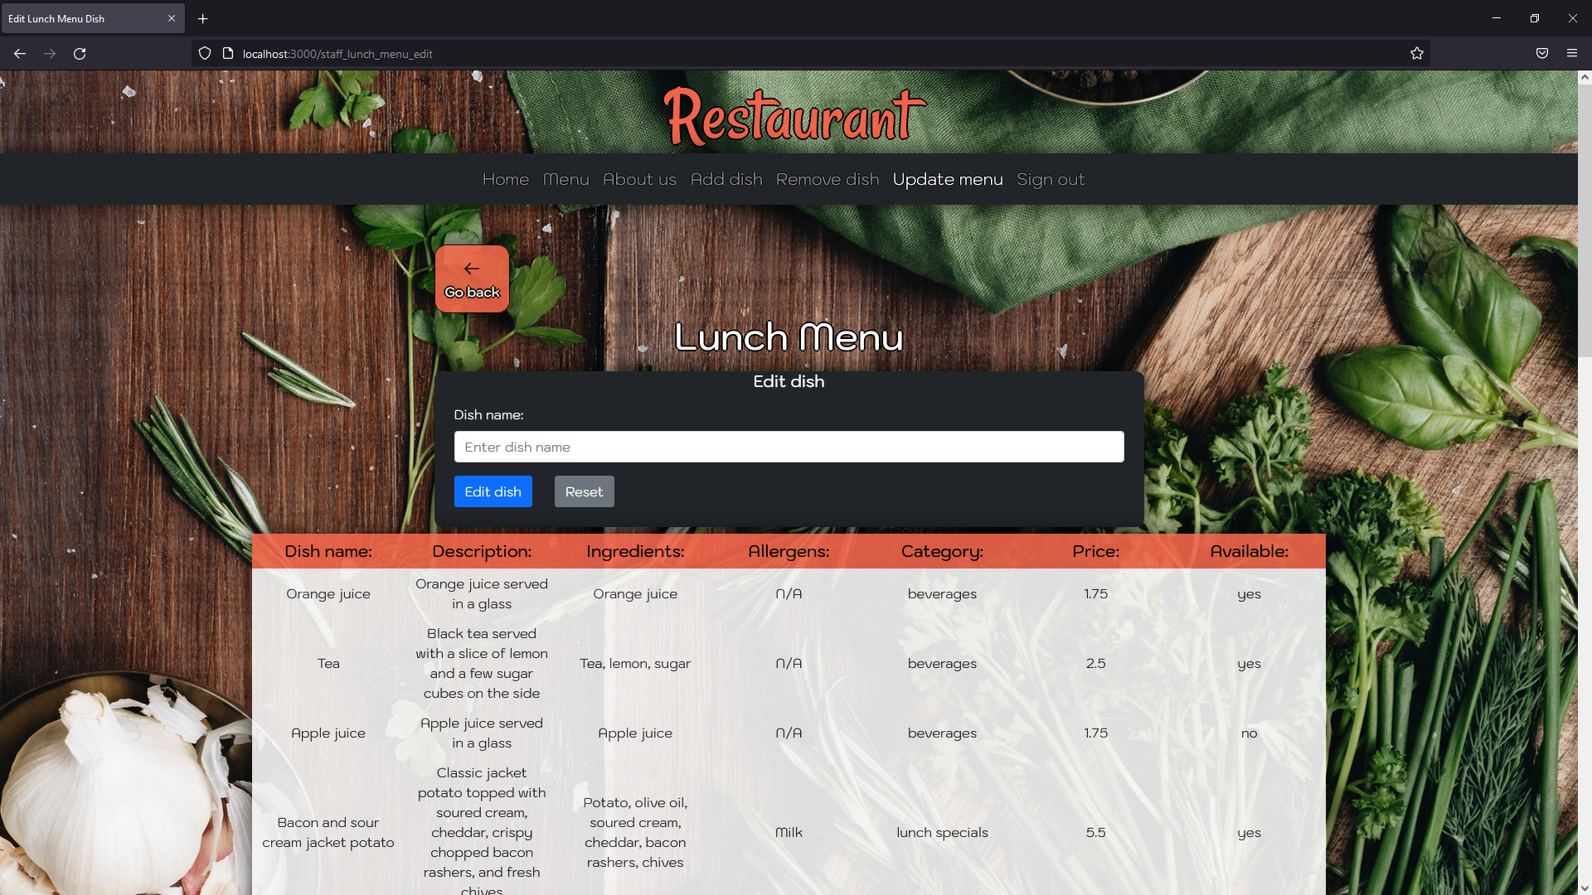

Figure 31 Update menu - Update lunch menu dishes

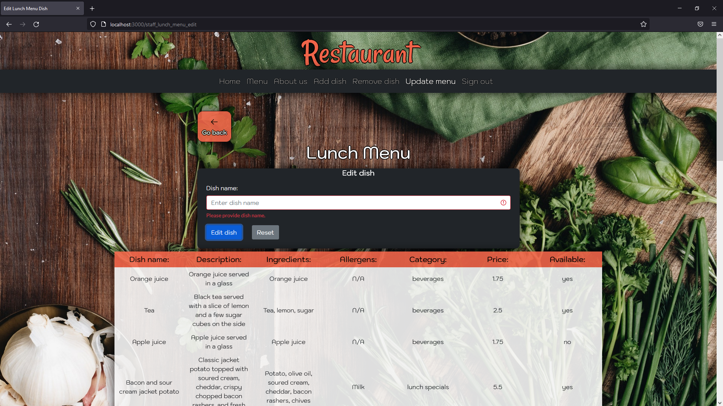

Figure 32 Update menu (lunch) - Empty form submitted

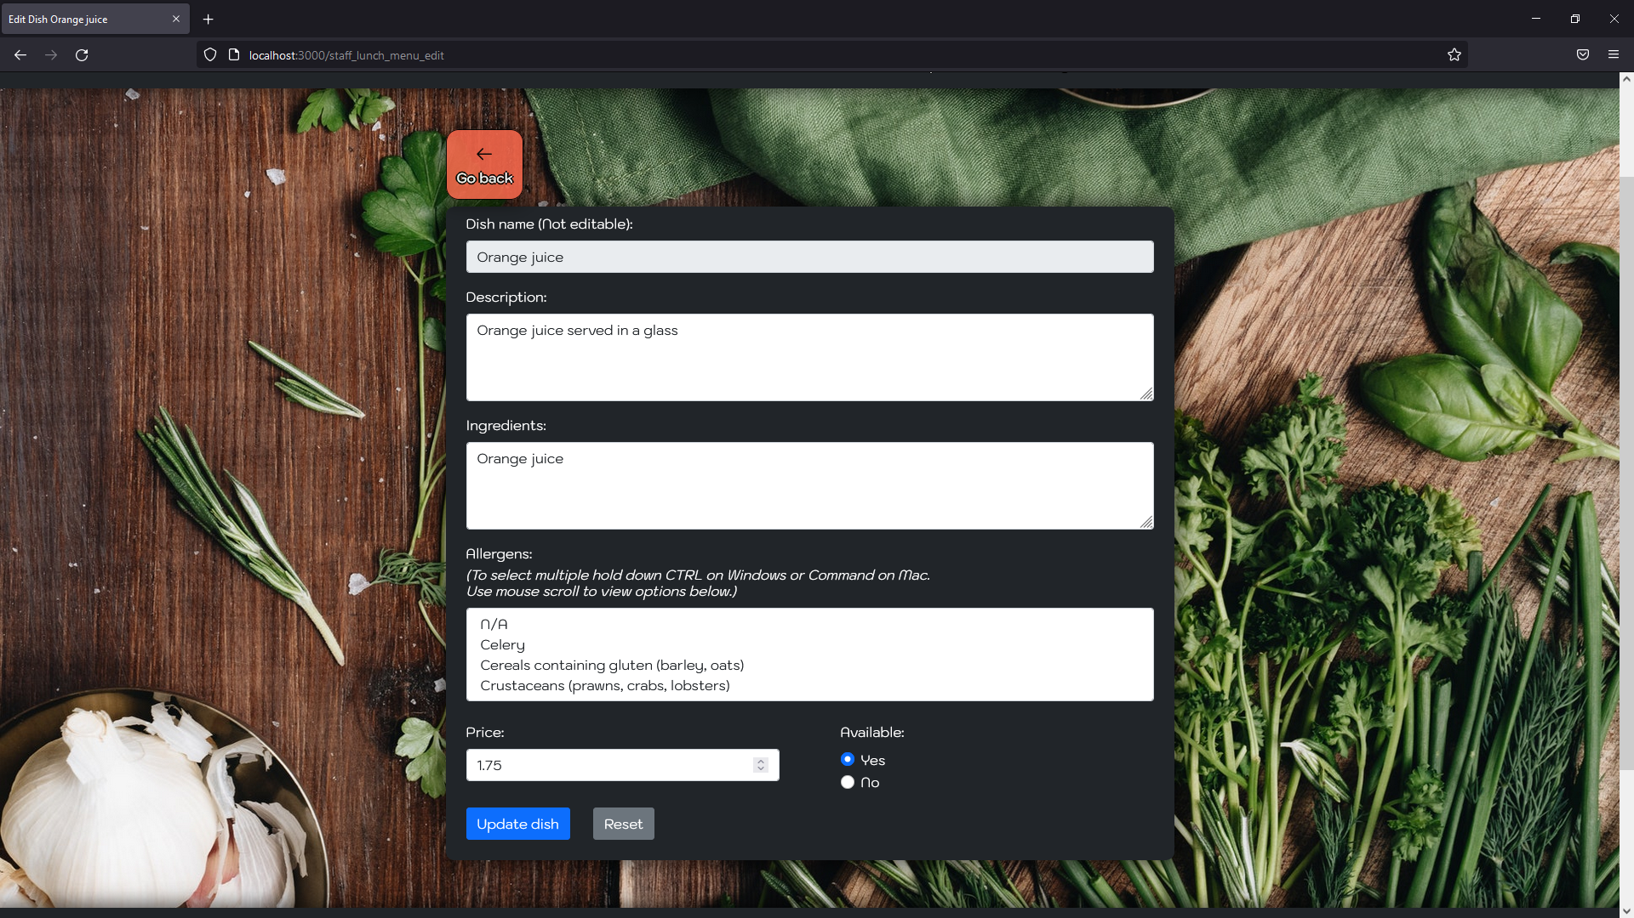

Figure 33 Update menu (lunch) - Orange juice

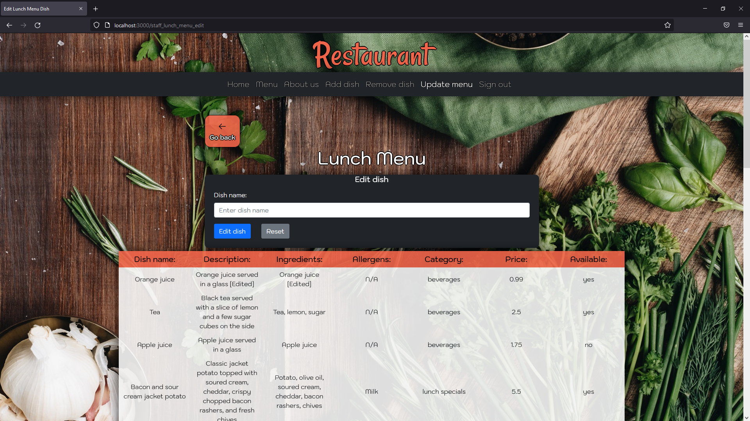

Figure 34 Update menu (lunch) - Orange juice edited

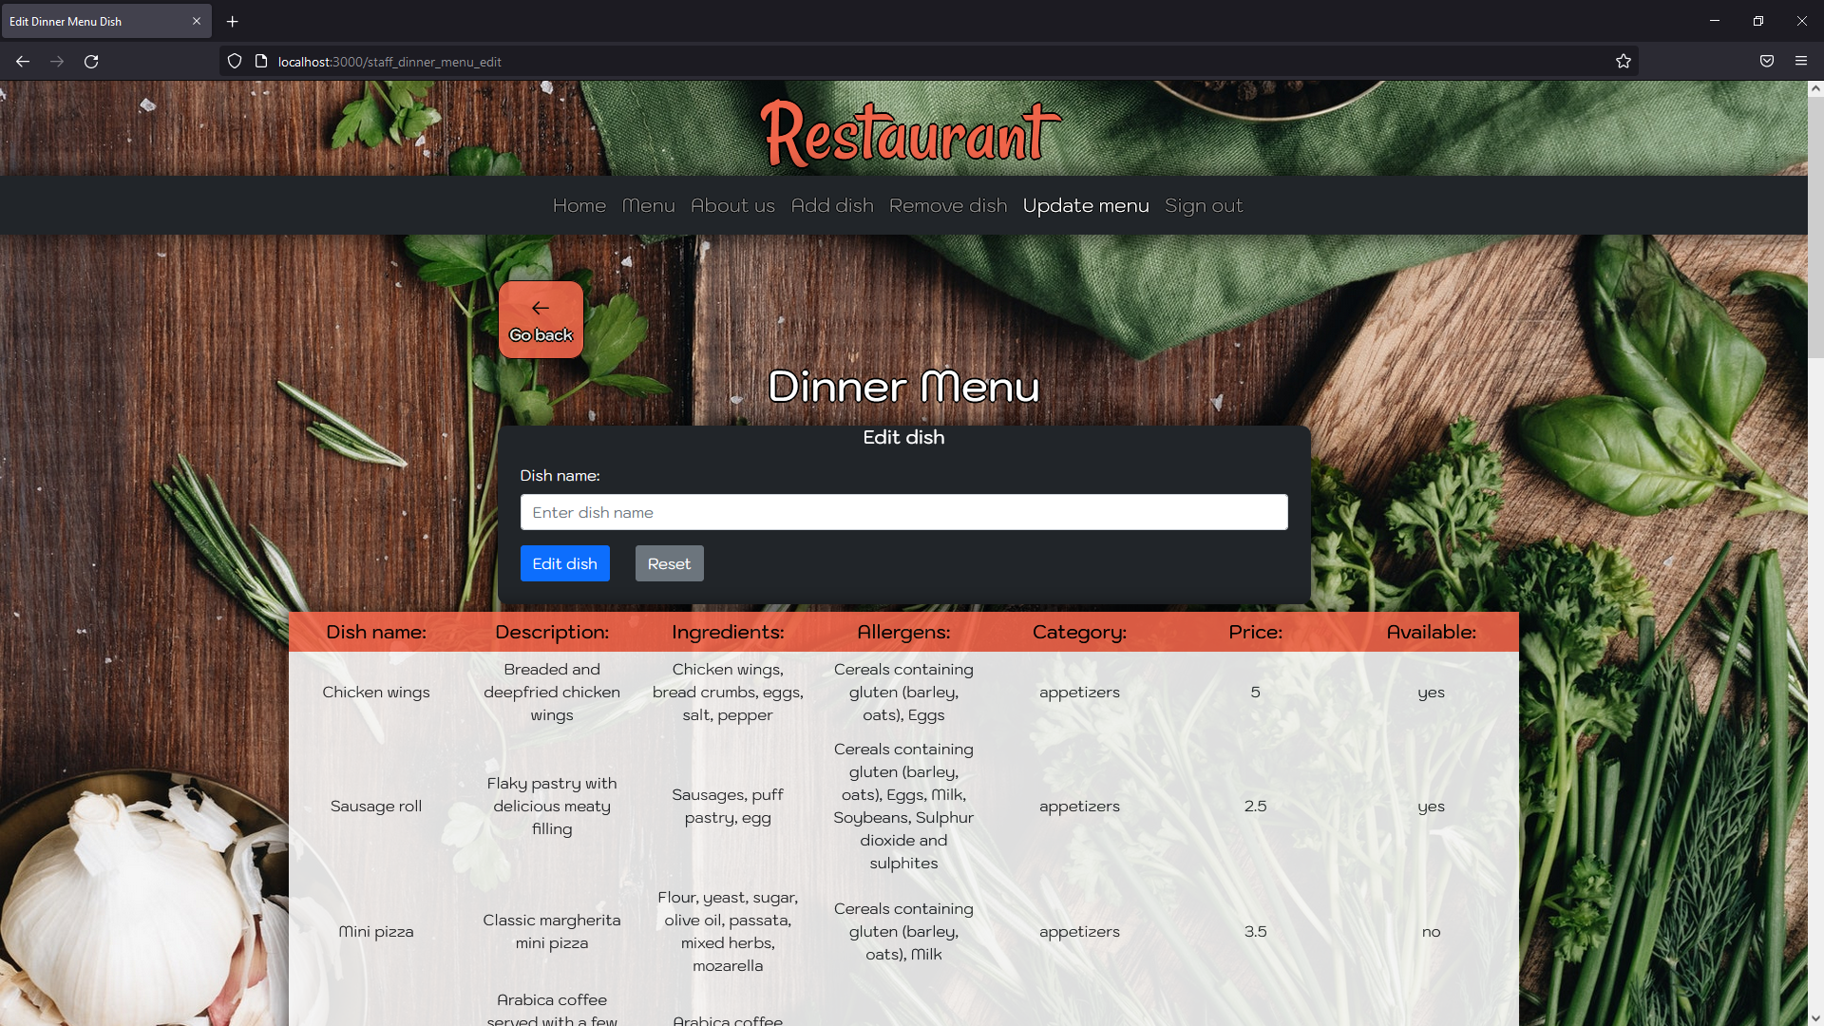

Figure 35 Update menu - Update dinner menu dishes

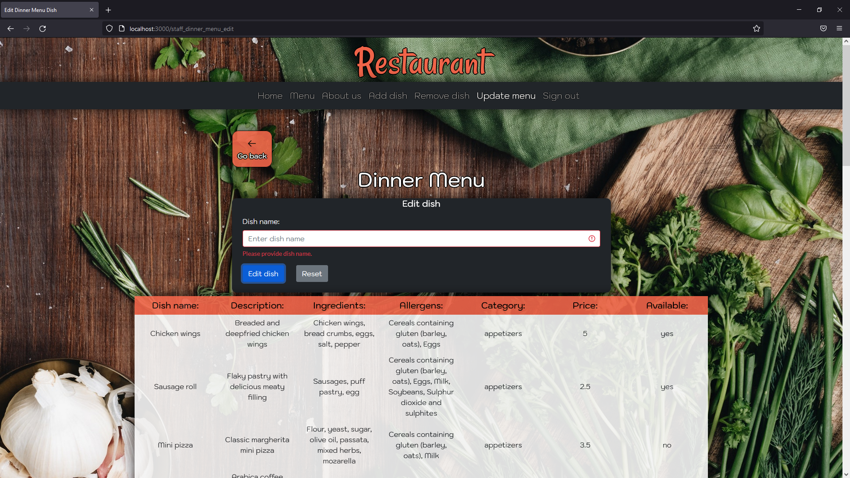

Figure 36 Update menu (dinner) - Empty form submitted

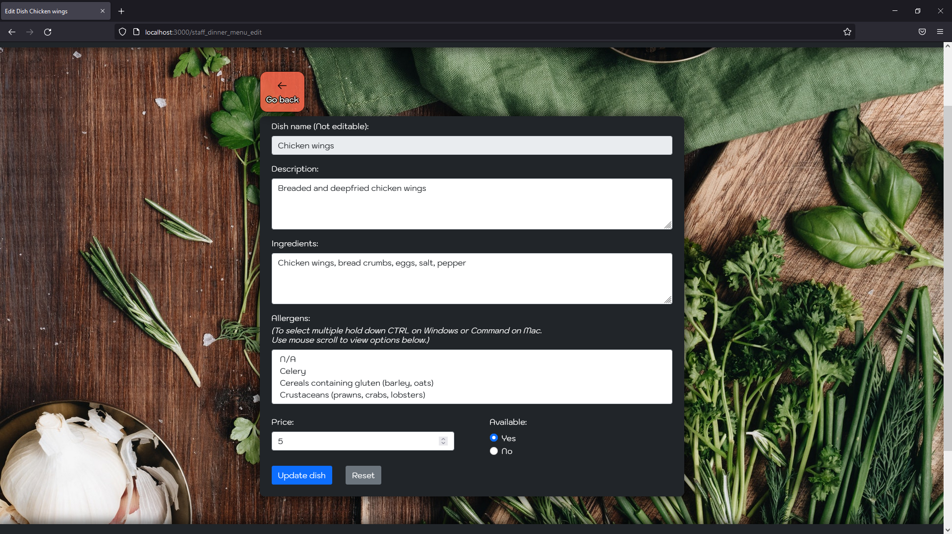

Figure 37 Update menu (dinner) - Chicken wings

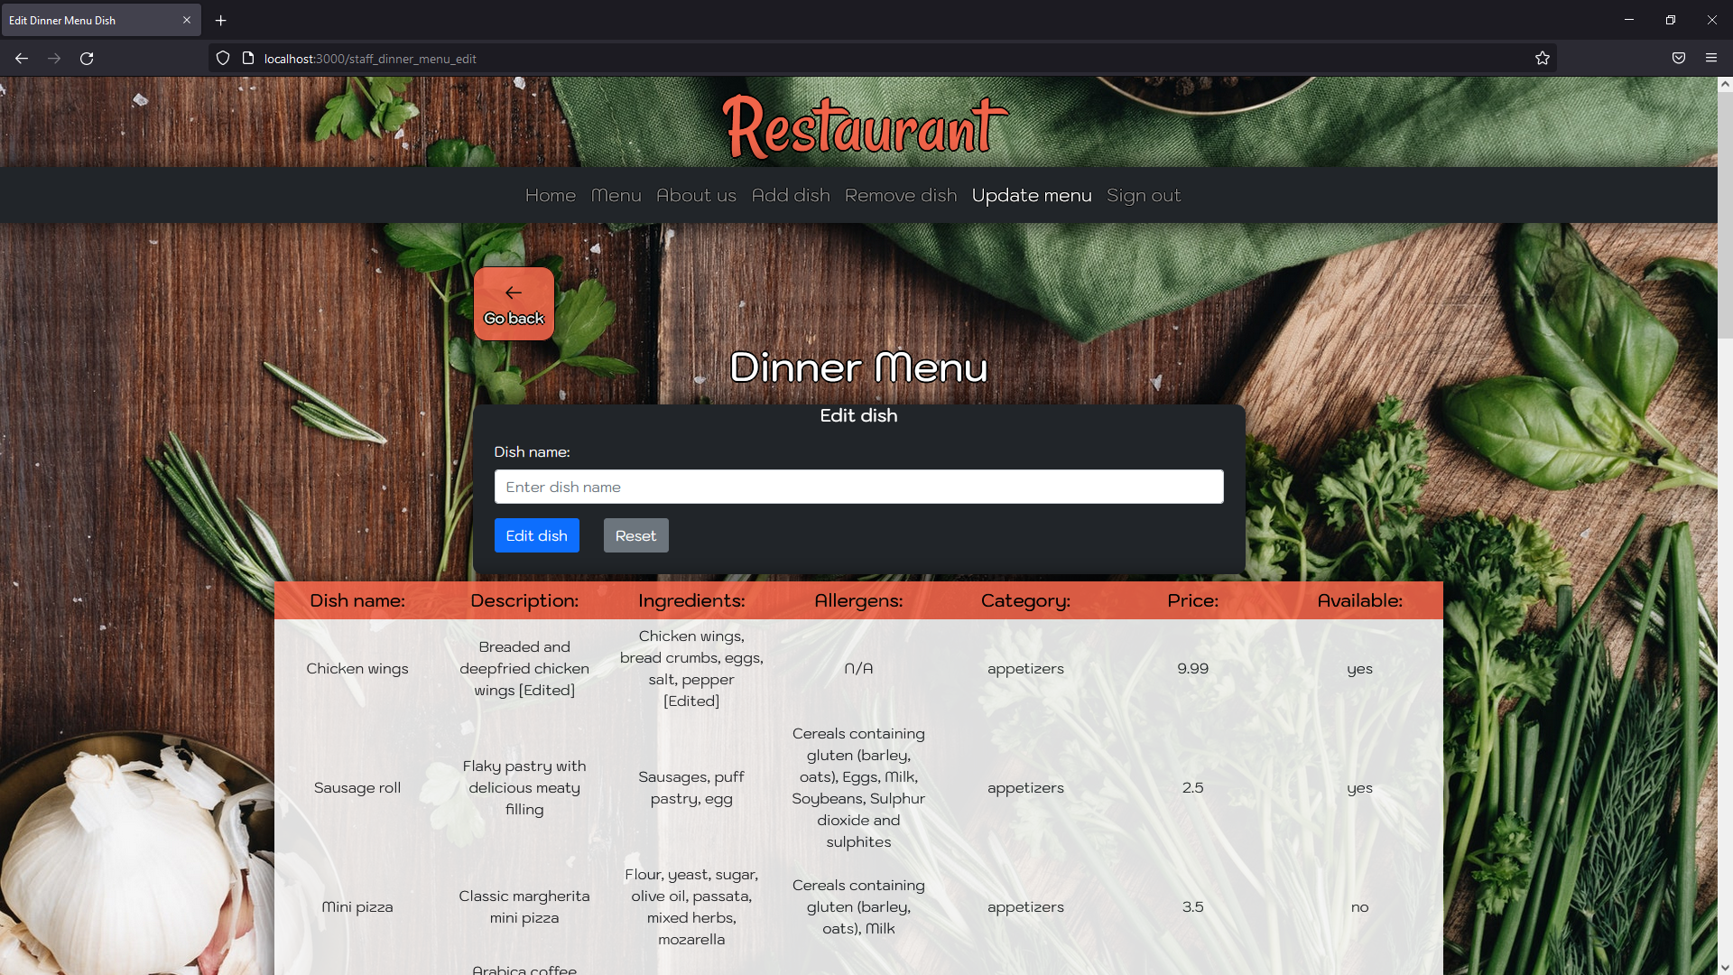

Figure 38 Update menu (dinner) - Chicken wings edited

# Summary of test results.

**Navigation bar** – as per Table 1 Navigation bar testing, the entirety of the use case tests has been passed.

**Footer** - as per Table 2 Footer testing, the entirety of the use case tests has been passed.

**Landing page/Homepage** - as per Table 3 Landing page/Homepage testing, the entirety of the use case tests has been passed.

**Menu page** - as per Table 4 Menu page testing, the entirety of the use case tests has been passed.

**About us page** - as per Table 5 About us page testing, the entirety of the use case tests has been passed.

**Staff sign in/ sign out** - as per Table 6 Staff sign in page testing, the entirety of the use case tests has been passed.

**Add new dish** - as per Table 7 Add new dish page testing, the entirety of the use case tests has been passed.

**Remove dish** - as per Table 8 Remove dish page testing, the entirety of the use case tests has been passed.

**Update menu** - as per Table 9 Update menu page testing, the entirety of the use case tests has been passed.

As mentioned above, all the tables and use case test that such tables contain has been passed. Showing that the proposed system is adhering to the specification and requirements of the WAD2 Practical coursework: Development of a website for a restaurant, which are:

* Not logged-in users can access an About Us page with details of the restaurant and its philosophy, along with being able to view the details of current menus. Such details should include name of dish, description, ingredients, allergy advice, and prices.
* Staff members should be able to sign in, to the system and enter details of new dishes, but also update the menus that are displayed for not authorized users.
* Alongside these requirements, it was necessary for the web application to be developed using Node.js and Express.js. Furthermore, as an information storing system, NeDB had to be utilised.



# Deployment.

To view deployed application please click [here](https://webdev-cw2.herokuapp.com/).

Staff details:   
Username: staff

Password: staff123